AGRICULTURE TEACHING NOTES FOR FORM 3

TOPIC 1: PHYSICAL PROPERTIES OF SOIL
- These include texture, structure, colour, consistency, porosity, temperature and depth.
SOIL TEXTURE
- Soil texture refers to the degree of coarseness or fineness of soil particles.
- Soil texture can also be defined as the proportion of sand, silt and clay in the soil.
DETERMINING SOIL TEXTURE
- Two methods can be used namely mechanical analysis of soil and sedimentation.

- MECHANICAL ANALYSIS OF SOIL
- Soil is analyzed through sieving
APPARATUS
- Soil samples
- Four sieves with different mesh diameters (2mm, 0.2mm, 0.02mm and 0.002 mm)
PROCEDURE
- Take soil samples from the garden – about 50g
- Grind the soil sample in a mortar to break it into fine particles.
- Sieve the soil sample using the sieves in turn.
CONCLUSION
- Gravel will not pass through the sieve with 2mm wire mesh.
- Coarse sand will not pass through the sieve with 0.2mm wire mesh.
- Fine sand or silt will not pass through the sieve with 0.02mm wire mesh.
- Clay particles will pass through the sieve with 0.002mm wire mesh.

- SEDIMENTATION
APPARATUS
- 50g of fresh soil from school garden.
- 250cm³ measuring cylinder or Coca Cola bottle
- Water
- Sodium carbonate
PROCEDURE
- Put the soil sample (50g) in the 250cm³ measuring cylinder or 300ml Coca Cola bottle.
- Add about 150cm³ of water in the cylinder.
- Add about 10g of sodium carbonate (to help in the dispersion of the soil particles in the suspension).
- Cover the mouth of the measuring cylinder with your hand or palm and shake vigorously.
- Let the contents in the measuring cylinder settle for at least 1 hour.

CONCLUSIONS
- Organic matter or humus floats on top, followed by clay particles suspended in water, then a layer of silt and fine clay. This is followed by a layer of sand. Gravel settle at the bottom.
- Therefore, soil is a mixture of mineral particles (sand, silt and clay) and organic matter (humus).
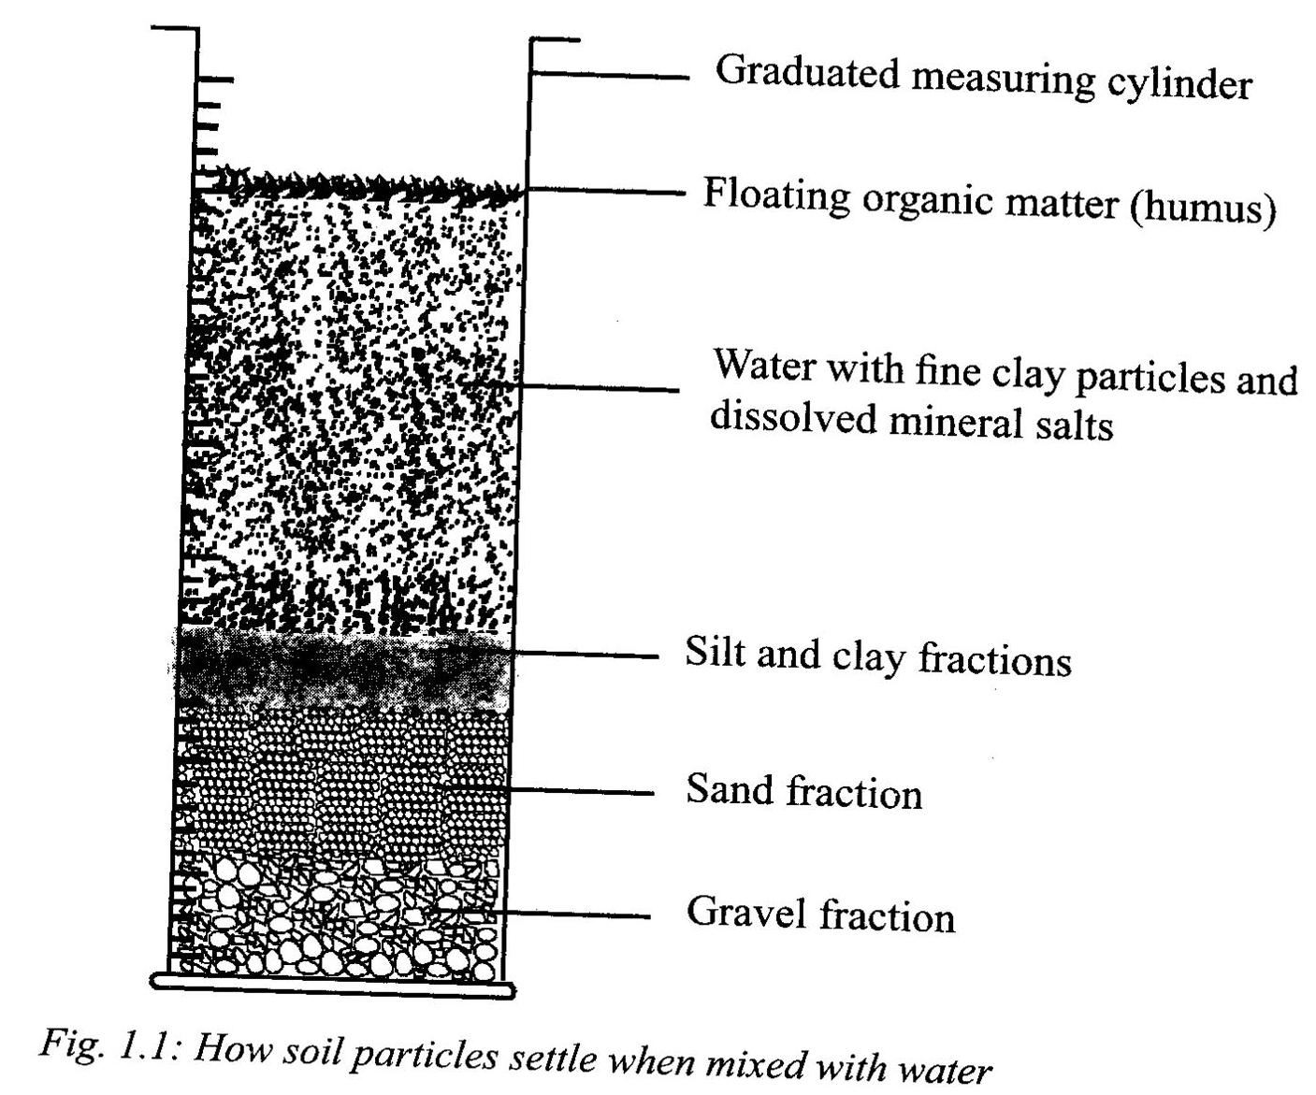
Figure 1.0
CLASSIFICATION OF SOIL PARTICLES

- Table below shows an International scale of soil particles
SOIL PARTICLE | SIZE (Diameter mm)
Gravel | Above 2.00
Course Sand | 2.00 – 0.20
Fine sand | 0.20 – 0.02
Silt | 0.02 – 0.002
Clay | Below 0.002

TEXTURAL CLASSES OF SOIL
There are three types of soil namely sand, clay and loam.
- Sandy soil contains more than 70% sand particles.
- Clay soil contains over 40% clay particles.
- Loam soil contains almost equal proportions of sand, clay, loam and silt in the laboratory using soil triangle (triangulation).
THE SOIL TRANGLE
How to use a soil triangle?
STEPS
- Collect a soil sample of about 20g.
- Grind it using the grinding mortar.
- Separate gravel and sand from the soil sample using sieving method (Use sieves of different mesh sizes i.e. 0.002 mm – 2mm)
- Weigh the amounts of gravel and sand separately.
- Use sedimentation method to separate silt and clay and weigh them.
- Express the various particle sizes of sand, silt and clay as weight percentage using the amount of dry soil as the basis. For example, if sand particles weigh 6g, this can be ⁶/₂₀ x 100= 30%, this means the soil sample had 30% sand particles.
- Use the weight percentages of sand, silt and clay to know the type of soil, a soil sample belongs to by using the soil triangle.

Assignment
- Put a Point N on the triangle (40% silt, 20% clay and 40% sand) and name the type of that soil
- Put a Point M (60% clay, 20% silt and 20% sand) gives a clay texture and name the type of that soil
DIAGRAM OF SOIL TRIANGLE
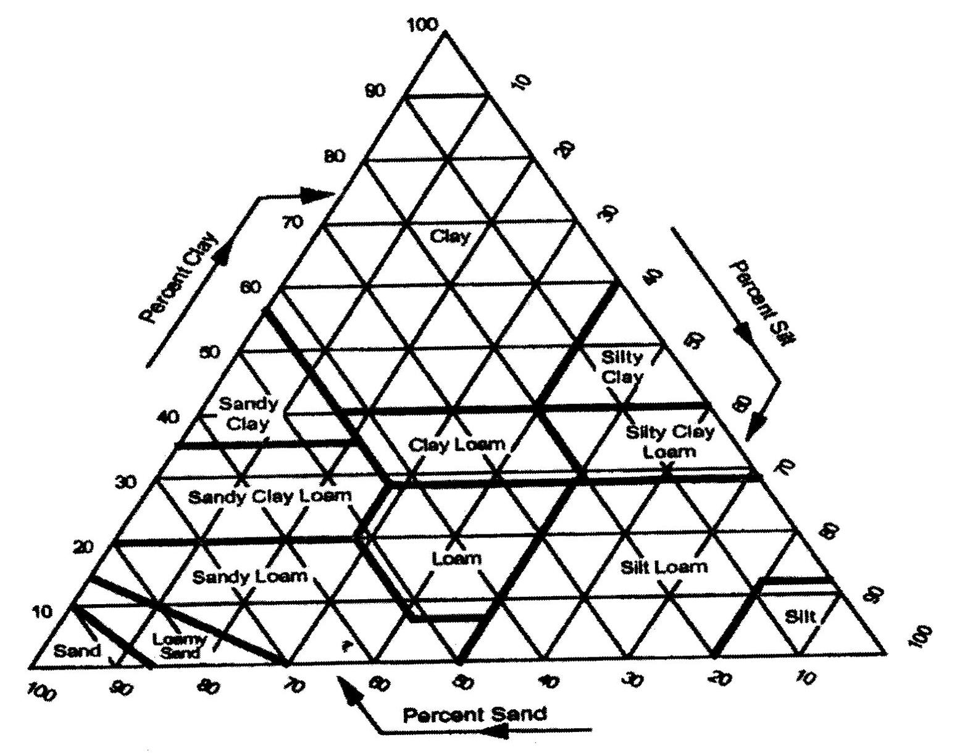
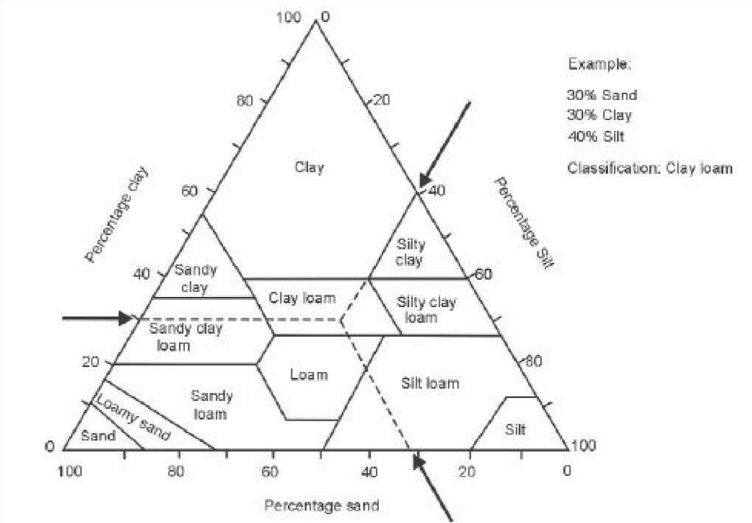

Fig 1.1: The soil triangle
CHARACTERISTICS OF DIFFERENT SOILS BASED ON TEXTURE.
- SANDY
- The particles are loosely packed and have a lot of air spaces.
- Sandy soils are well aerated.
- Sandy soils dry up easily.
- They hold very little water.
- Crops easily wilt, especially in dry season or when there is drought.
- Roots grow easily in sandy soil.
- Sandy soils are easy to cultivate.
- Sandy soils are well – drained but nutrients are easily lost through leaching.
B) CLAY
- The particles are tightly held together.
- The soil is poorly aerated.
- It is poorly drained (drains water slowly)
- It can easily become waterlogged.
- It holds a lot of water.
- It is poorly aerated
- It becomes sticky when wet and hard when dry.
- It is heavy to work on.
- Roots find it difficult to penetrate.
C) LOAM
- Has even mixture of sand, silt and clay.
- It is well aerated.
- It is well drained.
- It holds large amount of water.
- It contains a lot of plant nutrients.
- Crops grow well.
- Easy to cultivate.
THE EFFECTS OF SOIL TEXTURE ON CROP PRODUCTION
- It influences soil aeration: coarse – textured soils (sandy soils) allow air to circulate freely for root respiration and plant growth.
- It influences water – holding capacity: fine textured soils (clay) hold more water than coarse – textured soils for plant growth.
- It influences nutrient holding capacity: Nutrients leach more easily in coarse – textured soils, but are held firmly for crop production in fine textured soil.
- It influences soil drainage: coarse – textured soils are better drained for crop production them fine – textured soils.
- It influences tillage (ease with which the soil is cultivated): coarse textured soils are easier to till than clay which is fine – textured.
- It influences resistance to erosion: sandy soil is easily eroded than clay soil.
- It influences the type of crop to be grown. For example:
- Tobacco grows well in well drained sandy / clay loam soil.
- Maize grows well in well – drained sandy /clay loam soil.
- Cassava can tolerate poor soils but grows well in well –drained, rich, sandy loam soil.
- Cotton grows well in rich, sandy loam soil.
- Groundnuts, beans and soya beans require sandy or light loam soils.
- Rice grows well in heavy clay soils which retain a lot of water.
SOIL STRUCTURE
- It refers to the way sand, silt and clay particles are joined or arranged or packed together to form aggregates / collections.
- The aggregation of particles is made possible through cementing agents such as organic matter and clay.
TYPES OF SOIL STRUCTURE
- The following are types of soil structure:
- Single grain structure
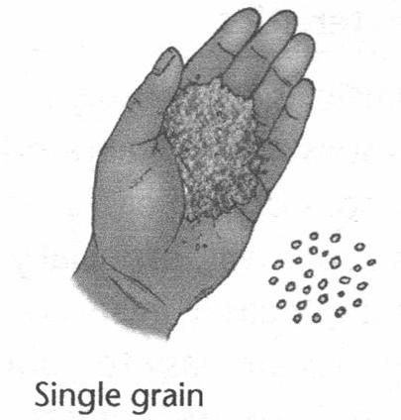
Figure 1.2
- Individual particles (single grains) can be identified.
- The particles are not aggregate or cemented together
- Each particle is on its own e.g. sandy soil.
- Granular structure
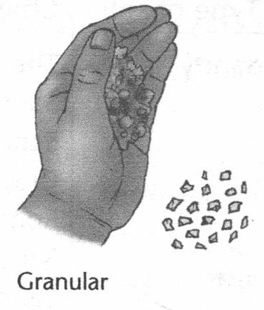
Figure 1.3
- Particles are loosely packed, forming aggregates that are round or avoid.

- Crumb structure
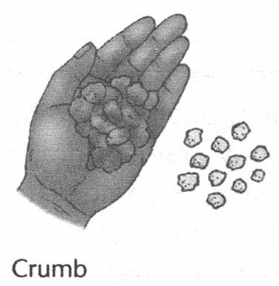
Figure 1.4
- Tiny soil particles are loosely joined to form friable, porous aggregates with irregular shape.
- This is the best soil structure for arable crop production as it ensures a suitable balance between soil aeration and water holding capacity.
- Platy structure
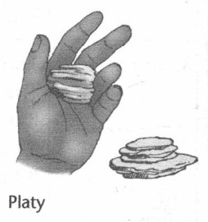
Figure 1.5
- Particles are horizontally arranged on a plane.
- They are flat and plate – like. Soils with such structure have low permeability

- Blocky structure
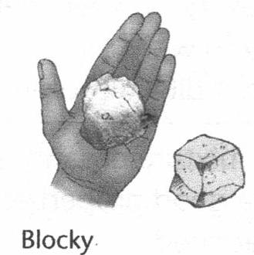
Figure 1.6
- Particles are joined to form six – sided rectangular lumps (blocks).

- Cuboidal structure
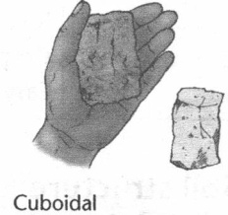
Figure 1.7
- Soil particles are joined together to form cubes or cube – like structure / shapes.
- Columnar structure
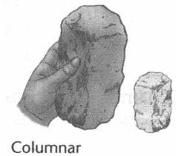
Figure 1.8
- Particles are cemented together to form vertical cylinders (columns) with round tops.
- Prismatic structure
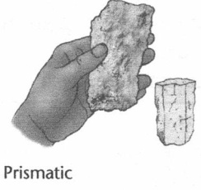
Figure 1.9
- Particles join to form vertical pillar (prism) with flat tops.
HOW SOIL STRUCTURE CAN BE DESTROYED.
- Cultivating it when it is too wet or too dry.
- Over – cultivating which disturbs the arrangement of the soil particle.
- Using heavy machinery which compacts the soil and even breaks down the soil structure.
- Applying unsuitable chemical fertilizers for example application of sodium compounds to the soil causes deflocculating (breakdown ) of soil structure.
HOW SOIL STRUCTURE CAN BE IMPROVED
- Cultivating it at the right moisture content or consistency. Clay soils become sticky when wet and hard when dry.
- Protecting soils from raindrops impact by planting vegetative cover like grass, close growing crops like groundnuts and sweet potatoes.
- Using machinery properly.
- Adding manure and organic matter which produces a cementing effect (Humus has a binding effect on sandy soil).
- Liming promotes aggregation of fine soil particles.
- Using fibrous rooted crops which help in binding the soil particles.
EFFECTS OF SOIL STRUCTURE ON CROP PRODUCTION
- Air circulation in the soil
- Single grain structured soils allow better movement of soil air for plant roots to respire than platy soil
- Water – holding capacity of the soil

- Nature or type of mineral elements in the soil:
- Red soils show that the soil has lots of iron oxides.

SOIL CONSISTENCY
- It refers to the strength with which the soil particles remain held together.
- It can also be defined as the resistance of soils to deformation or rapture at various moisture contents to mechanical stresses or manipulations.
- Soil consistence is measured for wet, moist and dry soil samples by feeling between the thumb and fore finger. For example, for wet soils it is expressed in terms of stickiness and plasticity.
- Plant growth is restricted by low and high levels of soil moisture, so it is important to maintain a good balance for crop production.
EFFECTS OF SOIL CONSISTENCY ON CROP PRODUCTION
- It influences water holding capacity of the soil.
- It influences workability of the soil i.e. farmers will plan when to cultivate the soil.
- Soil should be cultivated when it has the right moisture content. It should neither be too dry or too wet.
- Soil can be destroyed if cultivated when it is too dry. The soil particles breakdown easily into dust and can be eroded.
- When cultivated wet, soil sticks to implements puddles.
- Clay soils are hard to work with when too wet or too dry.
SOIL POROSITY
- Soil porosity is the condition of the soil to allow water and air to pass through it.
- Porosity is the proportion of the volume (total) of soil that is taken up by pore spaces.
- Porosity of the soil is due to the presence of air and water spaces. There are called pore spaces.
- When soil particles are close together as in sandy soil, the total porosity is low.
- Porosity in clay soil is high because the air spaces though tiny are many.
- Pore spaces can make up as much as 40% sandy soils and over 50% other soils.
- The pore spaces in sandy soil, which are large in size, mostly influence air flow.
- Porosity is associated with soil structure. Any measures taken to improve soil structure will improve its porosity.
- Continuous cultivation which destroys soil structure may decrease soil porosity.
BULK DENSITY
- It is an important term associated with soil porosity.
- Density is the mass (weight) per unit volume i.e. D = $\frac{M}{V}$
- Bulk density is the sum total of the pore spaces and solid particles of the soil.
- The formula for measuring bulk density is: BD= $\frac{W}{V}$ where BD = bulk density; W = weight of oven dry soil; V = volume of oven dry soil.
- Bulk density takes into consideration both the solid component and the pore spaces of the soil.
- Bulk density is used to determine the porosity of the soil; as shown in this equation:
- % porosity = $\frac{\left(100-bulk density\right)x }{particle density}$ x 100
- Bulk density of clay soil is about 1.00g /cm³.
- The figure 2.65g/cm³ is generally regarded as the average particle density.
- The percentage of air and water in an ideal soil is about 50%.
- Percentage porosity depends on the soil texture. It ranges from 40% in sandy soil to about 60% in clay soil. Loam soil is about 55% porous.
EFFECTS OF SOIL POROSITY ON CROP PRODUCTION
- It determines the rate of water – holding capacity of soil:
Sandy soil is more porous hence it holds little amount of water.
- It affects the rate of leaching of mineral salts:
The rate of leaching is low in clay soil since it is less porous. More nutrients are available for plant growth and development
- It also affects air movement in the soil: Sandy soil is porous allowing free movement of air for root respiration.

SOIL TEMPERATURE
- It refers to the measurement of the warmth in the soil.
- Ideal soil temperatures for planting most plants are 18 to 24˚C.
- Soil temperature is the factor that drives germination, flowering, composting and many other processes.
HOW SOIL TEMPERATURE IS DETERMINED?
- Scientists use a soil thermometer to determine soil temperature.
- They push the thermometer into the soil and wait to see consistent readings for a few days.

FACTORS INFLUENCING SOIL TEMPERATURE
- Soil colour:
- Dark soils tend to absorb more heat energy from the sun than soils which are light in colour.
- Moisture content of the soil:
- Clay soils tend to be cold and wet because of their texture and structure.
- Sandy soils warm up quickly; plants grow faster but may wilt easily because water drains quickly.
- Season of the year:
- The soils are exposed to sunlight longer in summer than in winter.
- Slope of the land:
- A garden which slopes towards north in the southern hemisphere is heated more than land which faces south.
- Vegetative cover:
- Soil temperature does not fluctuate much under vegetative cover as it does when the soil is bare.
- Bare soils warm up easily during the day and cool off more rapidly at night.
- Soil depth:
- Top soil experiences more temperature variations or fluctuations than sub soil.
WAYS OF MODIFYING SOIL TEMPERATURE
- Mulching crops
- Planting vegetative cover
- Irrigating and draining the soil to reduce the temperature
- Applying organic manure.
EFFECTS OF SOIL TEMPERATURE ON CROP PRODUCTION
- Seed germination
- Speeds up when the soil is warm and slows down when it is cold.
- Root growth
- Plant roots grow best at 25˚C. They are more prone to injury at high temperatures.
- Chemical reactions
- Speed up when the soil is warm and affects availability of plant nutrients.
- Transpiration and evaporation:
- The high the temperature, the greater the evaporation, transpiration and evapotranspiration.
- Breakdown of parent material:
- Temperature changes alternate hot and cold weather facilitate weathering of rocks (soil formation) so that crops have a better medium for growth.
- Activities of micro-organisms or microbes in the soil
- These are essential for decomposition of organic matter and nitrification (formation of nitrogen compounds in the soil).
- Nitrification proceeds at an optimum temperature between 25˚C and 32˚C and stops at a temperature of 95˚C.
- Nitrification ceases when temperatures are below 5˚C.
SOIL DEPTH
- It refers to depth of soil profile from the top to parent material or bedrock.
- Very shallow soils: less than 25cm
- Shallow soils: 25-50 cm
- Moderately deep soils: 50-90 cm
- Deep soils: 90-150 cm
- Very deep: more than 150 cm
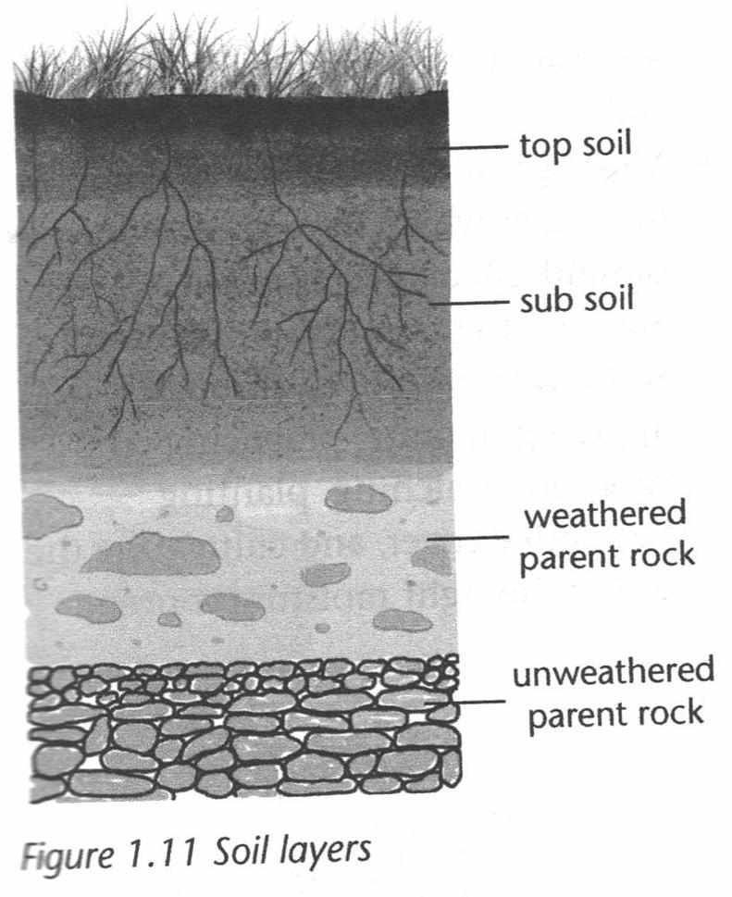
Figure 2.0: Soil Layers
- Soils which are well-developed and mature tend to be deep.
- Deep soils have a very deep top soil layer. They also have a deep, well developed sub – soil layer.
- On the other hand, shallow soils have thin layers of top soil and sub soil.
EFFECTS OF SOIL DEPTH ON CROP PRODUCTION
- Root development
- The deeper the soil, the easier and faster the roots grow.
- Shallow soils hinder root development since rocks become serious obstacles in the root zone.
- Amount of soil water
- The deeper the soil, the greater the water – holding capacity for crop production.
- Shallow soils keep low volumes of water.
- Soil aeration
- The deeper the soil the greater the aeration in the soil for root respiration and development for increased crop production.
- Plant nutrition
- The deeper the soil, the deeper the nutritive top soil layer which has most of the organic matter and mineral nutrients.
- Microbial activity
- The deeper the soil, the greater the zone available for soil micro – organisms to break-down organic matter to release nutrients for plant growth.

TOPIC 2: CHEMICAL PROPERTIES OF SOIL
- These include Soil pH, Cation Exchange Capacity (CEC), salinity and Sodicity.
- They affect the availability of mineral elements essential for plant growth.
- They also affect the activities of micro –organisms.
- Micro – organisms contribute to the nutrients status of the soil through the decomposition of organic matter.
SOIL PH
- PH refers to the power of hydrogen or the concentration of hydrogen ions (H⁺) in the soil.
- Soil PH is used to describe the acidity or alkalinity of the soil.
- The ions that determine the soil pH are the hydrogen ion (H⁺) and hydroxyl ion (OH⁻).
- When these ions are in equal concentration in the soil, the soil is said to be neutral (pH 7).
- When the hydrogen ions in the solution are in greater concentration than hydroxyl ions attached to the soil particles, the soil is said to be acidic.
- PH scale ranges from 1-14.
- A PH of 7 is neutral.
- The soil is said to be acidic when the pH is below &, and alkaline above pH 7.
- The pH is referred to as low or acidic when it is below pH 7 and high or alkaline when it is above PH 7.

1 2 3 4 5 6 7 8 9 10 11 12 13 14
Acidic alkaline
Neutral
Figure 2.1: PH SCALE

- Soil PH is measured using a universal indicator.
- If the soil is acidic the indicator will turn red. The indicator will turn blue if soil is alkaline or basic.
FACTORS AFFECTING SOIL PH
- Leaching
- During continuous heavy rainfall, plant elements such as calcium (Ca⁺⁺), Sodium (Na⁺), magnesium (Mg⁺⁺) and potassium (K⁺) are leached down the soil profile.
- These elements are then replaced by hydrogen ions, which increase soil acidity.
- The use of acid – forming fertilizers.
- The continuous and heavy application of Sulphate of Ammonia makes the soil acidic.
- Microbial activity
- Microbial activity increases Soil PH as hydrogen ions are released during the decomposition of organic matter.
- The carbon dioxide which is produced by microbes dissolves in water and forms carbonic acid, which increases soil acidity.
- Poor drainage
- Sandy soils are more prone to leaching than clay soils.
- Soil PH tends to be lower in sandy soil than in clay.
- Nutrient uptake by plants.
- When the crops are harvested, the nutrients absorbed by the plants are also lost from the soil.
- The lost nutrients tend to be replaced by hydrogen ions, which lower the soil PH.
- Weathering of parent material.
- Soil formed from limestone have a high PH
- The weathering of parent material may result in the accumulation of such ions as K⁺, Na⁺ Ca⁺⁺ and Mg⁺⁺. These tend to increase soil PH.
- When the parent material contains Sulphur, the soil becomes acidic due to the formation of Sulphuric acid.
- Type of vegetation.
- Soils in the forest tend to have a high PH than those in the grasslands, where loss of nutrients through leaching is reduced.
THE EFFECTS OF SOIL PH ON CROP PRODUCTION
  - Soil PH affects the type of crops to be grown in a particular area.
- Some crops do well under acidic conditions and others do well under alkaline conditions .
- Tea, pineapples and berries do well in acidic soil. Beans, peas soya beans groundnuts, cabbages and sunflowers prefer alkaline soil.
- Maize, wheat and sorghum do well under moderate pH (pH 6 and 7).
- Millet, rice, cotton, watermelon and cowpeas do well when the PH is between 5 and 6.5
  - Soil PH affects the availability of soil nutrients needed for plant growth.
- It is known that elements such as zinc (Zn) and Cobalt (Co) become less available in the soil with a PH above 5.5.
- Molybdenum becomes less available in the soil with a pH between 5.5 and 9.
- Nitrogen (N) Potassium (K) and Sulphur (S) become readily available when the PH is above 5.5.
- Calcium (Ca) and magnesium (Mg) become available when the soil pH is between 6 and 8.5.
- Phosphorus (P) is locked up in the soil if a pH is between 6 and 7.
  - It also affects microbial activities in the soil.
- Microbes such as bacteria tend to be active when the pH is above 5.5.
- Fungi tolerate a wide range of soil PH.
- Nitrification and nitrogen fixation by bacteria takes place vigorously at pH 5.5.In general, beneficial micro-organisms tend to function well in soils between pH 5.5 and 7.5

MODIFICATION OF SOIL PH
- Applying agricultural lime which contains calcium oxide.
    - Agricultural lime when applied to the soil neutralizes soil acidity.
b) Applying inorganic fertilizers such as ammonium sulphate decreases soil pH i.e. makes the soil acidic
c) Applying organic manure e.g. Khola manure reduces soil acidity.
SALINITY
    - It refers to the accumulation of soluble salts in the soil.
_
    - Salts that may accumulate in the soil include nitrates (NO₃ ) Sulphates (SO₄⁺), bicarbonates and chlorides (Cl⁻)
    - Soils which have a high concentration of soluble salts are called saline soils
CAUSES OF SOIL SALINITY
    - Soils become saline because of the following reasons:
- Irrigating, virgin land with poor quality irrigation water.
    - As the water evaporates, the salts build up in the soil
- The application of inorganic fertilizers, which may lead to build up of salts in the soil.
- Salts being released into the soil because the parent material contains a lot of salts.
- Low rainfall and evaporation
    - Salts accumulate on and below the soil surface due to capitulary action.
    - They also accumulate because there is limited leaching.
- Poor drainage
    - Salts tend to build up in the soils with poor drainage.
CHARACTERISTICS OF SALINE SOILS
    - Salts tend to accumulate on the surface of the soil as white substances.
    - Soils containing salts tend to be liked by goats and cattle.
    - Water stressed plants, leaf tip burn.
SODIC SOILS
    - These are soils with very high concentrations of sodium.
    - Sodicity means the amount of sodium held in the soil.
    - Sodic soils are caused by poor drainage
    - Sodic soils are characterized by black powdery residence on soil surface.
SALINE –SODIC SOILS
    - These are salt-affected soils with high sodium concentration.
    - They are grey –coloured soils.
    - Plants showing water stress.
THE EFFECTS OF SALT ACCUMULATION
- When salts build up in the soil, they raise soil PH (make the soil alkaline)
    - Some nutrients, for example potassium, iron, boron and manganese become unavailable to plants when PH is high.
    - Alkalinity also affects the availability of Mg, Fe and Ca.
- The accumulation of salts in the soil affects seed germination and plant growth in the following ways:
    - It affects the availability of water due to high osmotic concentration the soil solution.
    - High osmotic pressure reduces the ability of plant roots to suck in water.
    - There is high level of exchangeable sodium
    - Exchangeable (Na) affects the physical and chemical properties of soil.
    - When there is excess Na, Clay is dispersed resulting in a aggregates being broken down. This in turn reduces the permeability of the soil.
- Salts may also be toxic to crops
    - Crop sensitivity to salts varies according to type and varieties
    - Some crops are sensitive to a high concentration of salts while others may tolerate the salts.
Table below shows the sensitivity of some crops to salts.

LOW SALT TOLERANCE | MEDIUM SALT TOLERANCE | HIGH SALT TOLERANCE
green beans | Rice | cotton
Field beans | Sorghum | Spinach
Apples | Maize | Rape
Pears | Wheat | Barley
Apricots | Tomatoes | Sugar beets
citrus | Oats

DETERMINING SOIL SALINITY
    - Soil salinity can be determined by conducting a field test using a calibrated salinity meter or doing laboratory soil analysis as done at Bvumbwe and Chitedze research stations
    - The field test for salinity is also called an EC 1:5 (i.e. EC one – to five) test.
    - This is because or ration of 1 part of soil sample to 5 parts distilled or rain water is used to find the salinity of the soil sample.
STEPS IN SOIL SALINITY TEST
- Assessing or determining the texture of the soil sample.
- Measuring the salinity of a solution made up of distilled water mixed with soil sample
    - It is collated using a salinity meter. The ratio of soil sample to water should be 1:5 hence referred to as EC 1:5.
- Multiplying the test result (salinity meter reaching) by the conversion factor based on soil texture to get soil salinity (ECE) which shows how soil salinity affect plant growth.
    - The conversion factors are indicated in the table below.

SOIL TEXTURE | MULTIPLICATION FACTOR
sands | 17.0
sandy loams | 13.8
loams | 9.5
clay loam and right clays | 8.6

MANAGING SALINE SOILS
There are several ways of managing Saline soils. These include
- Irrigation soil by flooding
    - The salts are flushed out and become leached
- Drainage
    - As the water is drained it carries some salts with it.
- The application of gypsum
    - Gypsum helps to convert insoluble carbonate salts into sulphates which are readily soluble and leached through irrigation.
- Preventing or reducing evaporation
- Growing salt tolerant crops.
NUTRIENTS STATUS OF THE SOIL
    - Soil contains different nutrients that are needed by crops for growth and development
FACTORS AFFECTING THE NUTRIENT STATUS OF THE SOIL
    - These include
- Soil salinity.
    - Accumulation of salts in the soil results in an increase in the soil PH
    - Increase in PH makes some of the nutrients (elements) such as magnesium, iron, calcium, unavailable to plants.
- Parent material
    - If the parent material contain a lot of nutrients such as magnesium, calcium, potassium, the soil formed will also contain those nutrients
- Soil structure and texture
    - These affect the nutrient status of the soil by influencing the physical and chemical properties of soil.
    - For example, granular structures hold a little amount of nutrients since most of them are leached down.
    - Fine textured soils such as clay soils hold a lot of nutrients since there is minimum leaching.
- Mono-cropping
    - If a farmer grows the same crop on the same piece of land continuously, they deplete nutrients from the same root zone
- Soil acidity
    - It affects both the release of nutrients and microbial activities in the soil.
- Soil acidity
    - It affects both the release of nutrients and microbial activities in the soil
- Soil erosion
    - The loss of soil nutrients from the top soil through erosion by water or wind is a major factor.
- Excessive irrigation
    - If the land is heavily irrigated it results in nutrients being reached and the nutrients in the top soil washed out.
- Mineral uptake by the plants and crop removal
    - This contributes to the loss of nutrients since the nutrients are moved with crops as they are being harvested.
    - This happens where the crop residue are not returned to the soil drainage
    - When waterlogged land is drained to remove surplus water some nutrients get washed away in the process as well
    - Leaching of basic nutrients
    - Soluble nutrients, e.g nitrates, are washed down the soil profile.
CATION EXCHANGE CAPACITY (CEC)
    - Cation exchange capacity refers to ability of the soil to absorb or hold and exchange or release cations.
    - The nutrients are in the form of positively charged ions, called cations and negatively charged ions called anions.
    - Examples of cations are Ca⁺⁺, Mg ⁺⁺ Na⁺ and K⁺
    - Examples of anions are Cl⁻, N0₃ – etc.
    - The cations are held or absorbed into the soil colloids
    - Anions are found in the soil solution
    - The cations are not easily leached from the soil. However they can be replace by or exchanged with the soil solution through cation exchange capacity.
    - Clay soil is negatively charged
    - CEC is high when the soil has many negative charges and CEC is said to be low if those are a few negative charges as compared to positive charges.
WAYS OF IMPROVING CEC
- Application of organic manure
    - Organic manure is negatively charged hence it has the capability to attract cautions.
- Incorporation of clay particles
    - Clay soil is generally negative it has the ability to attract cautions.
EFFECTS OF CEC ON CROP PRODUCTION
- Reduces leaching of nutrients
    - Cations are strongly attracted the soil particles hence they are not washed down the soil
- It influences microbial activity
    - Soil with low CEC have reduced microbial activity due to the presence of acid which is not the conducive environment for microbes
- It influence water holding capacity
    - Soil with high CEC hold a lot of water due to presence of organic matter (humus)

TOPIC 3: AGRICULTURAL DEVELOPMENT AGENCIES AND THEIR SERVICES
- Agricultural services include:
- Research
- Extension
- Production credit
- Marketing
- Processing
- Infrastructure
MAIN AGRICULTURAL RESEARCH AGENCIES IN MALAWI
- These include :
- The Department of Agricultural Research services such as
- Agricultural Research Stations e.g. Chitedze, Makoka and Bvumbwe.
- Agricultural experimental centres.
- Agricultural Research and extension Trust (ARET)
- MONSANTO Malawi Limited (Seed Technology)
- Tobacco Research Institute of Malawi (TRIM)
- Lilongwe University of Agriculture and Natural Resources (LUANAR)
- International Research Institutions such as International Institutes of Tropical Agriculture (LITA) , International Livestock Research Institute (ILRI).
AGRICULTURAL RESEARCH ACTIVITIES
- These include :
- Testing soil samples to determine their fertility levels.
- Experimenting with husbandry practices such as spacing, weeding, watering and Fertilizer application.
- Breeding crops and Livestock in order to increase yield.
- Developing improved inputs such as herbicides, pesticides, Livestock feeds and drugs
- Designing and testing improved technologies including farm machinery.
- Experimenting with various farming systems and making recommendations.
IMPORTANCE OF AGRICULTURAL RESEARCH SERVICES TO THE GROWING POPULATION.
- Agricultural research is important in the following ways:
- It produces high yielding crop varieties and livestock breeds.
- It increases farm income by increasing yield per unit area or per animal
- It introduces new methods of crop and animal husbandry.
- It comes up with better ways of reducing post harvest losses in storage.
- It finds out better ways of reducing the negative effect of climate change, pests, parasites and diseases in crops and livestock.
- It enables farmers to obtain high quality products from their crops and livestock.

AGRICULTURAL EXTENSION SERVICES
- Agricultural extension refers to the system of transferring information from researches to farmers.
- The aim of agricultural extension is to provide technical information, advisory and support services to smallholder farmers to enable them to increase crop and animal production.
AGRICULTURAL EXTENSION ACTIVITIES
- These include :
- Advising smallholder farmers on a particular enterprise in order to increase production
- Training farmers to change attitudes and improve their knowledge and skills as farmer groups in their areas.
- Conducting campaigns where new technologies /one displayed in order to attract and persuade farmers to try them out in their fields.
- Arranging field days in Extension planning Areas (EPA)
- Producing agricultural publications such as posters. Pamphlets, Leaflets and magazines.
- Holding Agricultural shows where farmers display their products and learn from one another.
- Conducting farmers group meetings.
AGRICULTURAL EXTENSION AGENCIES
- These include:
- The Department of Agricultural extension services which include:
- Agricultural Development Divisions (ADD)
- District Agricultural Development Offices
- Extension planning Areas.
- Non Governmental organizations for instance:
- Development Aid from people to people (DAPP)
- Hunger project and concern universal
- Private Extension companies such as:
- National smallholder farmers Association of Malawi NASFAM
- One Acre Fund
- The smallholder Coffee farmers Trust
- Horticultural Development Organization of Malawi.
- Manufactures and suppliers of agricultural inputs
Such as:
- Agricultural Trading Companies (ATC)
- Proto Feeds Ltd
- Charles steward Day Old chicks Ltd
IMPORTANCE OF AGRICULTURAL EXTENSION TO THE GROWING POPULATION
- Bringing scientific knowledge to farmers such as modern farming practices and technology.
- Improving technology adoption by farmers through use of demonstration plot and Field visits
- Improving productivity of agricultural land per unit area.
- Developing capacity of farmers through provision of skills and knowledge so that they can farm more efficiently.
- Breaking the vicious cycle of poverty in the rural areas through the use of improved farming practices.
- Training farmers by advising them on improved farming practices for free.
- Promoting sustainable use of farming (natural) resources.
PRODUCTION CREDIT SERVICES
- Agricultural credit is the amount of money that a financial institution is prepared to lend a farmer
- Farmers need credit for various activities including:
- Financing farm development activities such as:
- Purchasing land
- Purchasing farm machinery
- Establishing irrigation facilities
- Constructing farm structures
- Financing seasonal farm production activities such as
- Purchasing seeds, fertilizers
- Purchasing feeds and drugs for livestock
- Paying wages to farm workers
- Financing marketing activities in order to get higher prices for the produce.
IMPORTANCE OF AGRICULTURAL CREDIT
- Increasing agricultural production
- Agricultural credit is used to buy fertilizer, the application of the fertilizer increases soil fertility.
- Increase income per unit of given resource
- If credit is invested it increases the output of the products, hence the farmer gets more money from the sales of the products.
- Improves nutrition and food security among farmers.
- Because of high farm yields, the farmers have adequate food all the times.
- Improving the welfare of farmers
- Increased farm income helps farmers to pay for the necessities such as machines and household goods.
- Increasing employment opportunities for rural people
- Provision of agricultural credit helps farms to expand.
- The farm will then have to employ more farm workers.
- Breaking the poverty cycle among farmers
- Provision of agricultural credit can get farmers out of poverty.
AGENCIES THAT PROVIDE FARM CREDIT IN MALAWI
- Commercial banks such as the National Bank of Malawi
- Savings and credit cooperative societies
- Malawi Rural Finance Company
- One Acre fund
- Non institutional agencies such as traders, friends and relatives.
  - These agencies are available in all extension planning areas.
AGRICULTURAL INFRASTRUCTURE SERVICES
- Agricultural infrastructure refers to physical and organization structures needed to support the operation of farm enterprise.
EXAMPLES OF AGRICULTURAL INFRASTRUCTURE
- Transport network such as roads and bridges, rail network, and pedestrian walkways.
- Communication systems such as postal, telephone, internet ,television and radio stations
- Water supply system
- Power (electricity) supply system
- Food storage facilities such as grain soils.
- Agricultural experimental centres and research stations.
- The network of ADMARC markets and cattle markets
- Livestock protection infrastructure such as dip tank, spray races.
IMPORTANCE OF AGRICULTURAL INFRASTRUCTURE TO THE GROWING POPULATION
- Facilitating the transportation of farm inputs through the use of tractors, ox-cats etc.
- Facilities such as irrigation infrastructures helps farmers to obtain high crop yield even when there is drought
- Promoting agricultural trade; a good communication system enables farmers to communicate with traders who buy their produce.
- Facilitating dissemination of agricultural information when roads are in good condition.
- Improving farm income: A good transport system reduces cost of transport, production and marketing. This increases the farmers’ profit.
AGENCIES THAT PROVIDE INFRASTRUCRURAL SERVICES IN MALAWI
- Rural Infrastructure Development (RIDP) focusing on roads and irrigation infrastructure.
- Ministry of Transport and Public Infrastructure
- National Road Authority
- Malawi Rural Development Fund (MARDEF)
- Ministry of Irrigation and Water Development
- Department of Veterinary Services
- National Water Development Programme.
PROCESSING SERVICES
- Processing involves changing the form of agricultural produce to a form which consumers prefer.
IMPORTANCE OF PROCESSING AGRICULTURAL PRODUCE
- Creating a market (processing industries) where farmers can sell their produce.
- Adding value to the produce so that farmers or the processor can gain more from selling the product.
- Providing employment to the population engaged in processing the produce
- Increasing the shelf life of the produce so that it can be kept in storage for long periods without loss in quality.
- Improving the taste of edible produce for the growing population.
AGRICULTURAL PROCESSING AGENCIES
PROCESSING AGENCIES | AGRICULTURAL PRODUCE | PRODUCTS
Universal Industries LTD | Cassava, potatoes, g/nuts, eggs, | Crisps, tambala nuts
Malawi Dairy Industries | Milk | Yoghurt, butter, cheese
Bakhressa | Maize | Maize meal, stock feeds
Chibuku Breweries | Maize | Chibuku beer
Nali | Chillies, peppers, tomatoes | abale samalani hot chilli, tomato sauce
Agro-feeds | Maize, soya beans | Stock feeds
Malawi mangoes LTD | Mangoes, bananas | Fruit juice

AGRICULTURAL MARKETING SERVICES
- Some of the marketing activities include:
- Buying: This involves obtaining something by payment.
- Selling: This involves offering something for sale (receiving money in return)
- Grading of the produce
- This involves sorting of the produce according to size, shape, colour and level of purity.
- Transporting the produce
- This involves taking the produce to places where consumers need them.
- Storing the produce
- This involves keeping or preserving the produce after harvest so that it can be sold at a later time.
IMPORTANCE OF AGRICULTURAL MARKETING SERVICES
- Providing inputs to farmers
- Farmers can obtain seeds, fertilizers, herbicides, drugs, equipment etc.
- Providing an income to farmers
- Farmers can sell their produce and earn money.
- Adding value to farm produce.
- It increases the monetary worth of the commodity so that farmers can gain more money.
- Providing foreign currency
- Exporting the produce such as tobacco, tea can increase the country’s foreign reserves.
- Distributing goods and services
- Commodities reach people in various places of the country through the transport function of marketing
- Encouraging farmers to use resources wisely to produce more and better quality products.

AGRICULTURAL MARKETING AGENCIES
These include;
- Agricultural Development and marketing corporation (ADMARC)
- Agricultural Trading company Ltd
- Tobacco Auction Holdings Ltd
- Farmers World.
TOPIC 4: FARM RECORDS AND ACCOUNTS
FARM RECORDS
- Farm records are written statements or detailed collection of facts and figures on agricultural activities, operations, practices and transactions.

THE IMPORTANCE OF FARM RECORDS
- Farm records are important because they:
- Assist in measuring efficiency
- Farm records allow farmers to determine how well resources are being used.
- Farm records can help the farmers to identify strengths and weaknesses in the farm business and take possible action to improve the situation in future.
- Help on determining profitability
- Farm records help farmers to calculate profit or loss.
- Assist in farm budgeting
- Farm records help farmers to forecast the expenses and anticipated income on the farm.
- Help in farm management decision making
- Farm records help farmers to determine which enterprises to expand reduce or abandon basing on profitability.
- Assist in income tax management
- Farm records help in evaluating the farm business so that the farmer is taxed fairly.
- Help in obtaining and managing credit.
- Farm records provide bankers with financial information they need for making credit decisions.
- Aid in comparative farm performance
- Good farm records help farmers to tell how well they are running their farm compared to neighbouring farms.
- Farmers can also compared the productivity of their farms with publishing standards such comparison is called benchmarking.
- The data for comparison may be farm profit , outputs or costs on that form.
- If the farm is above the standards the farmer can continue with his/her enterprise.

- If the farm is below the standards, the farmer must go and learn from others.
- Assist in monitoring progress.
- Farm records help the farmer to check whether the farm is improving or not.
- Assist in determining equity
- Equity = assets (property) – liabilities (debts)
- Good farm records will show the assets the farm has and their monetary value.
- Good farm records will also show all the liabilities (debts) of the farm.
- Assist in farm planning
- Farm records can be use to prepare for future farm activities such as breeding animals, harvesting crops, cutting animals, land preparation, fertilizer application etc.
- Provide a history of farming activities.
- Farm records kept over a long period enable farmers to make comparisons of production practices, yield and profits between seasons and between enterprises within the farm.
- Support insurance claims
- Farm records help farmers to claim compensation from insurance companies in case of theft , fire or loss of form assets or produce.
TYPES OF FARM RECORDS
- There are three main types of farm records namely:
- Inventory records
- Production records
- Financial records
INVENTORY RECORDS
- Inventory records are a list of all the properties or assets that the farmer has on the farm.
- Assets are things that can be converted into cash
- Capital items on the farm may include:
  - Farm houses: Manager’s and worker’s houses, animal pens, crop storage facilities etc.
  - Fruit trees and other perennial crops
  - Farm tools, machinery and equipment such as ploughs, disc hallows, cultivators, seed drills etc.
  - Land with details of hectare.
  - Farm produce in storage
  - Number and types of livestock kept
  - Farm inputs: seeds, fertilizers, drugs, pesticides and feeds.
- Inventory in Malawi is taken in the month of September, when farmers prepare for the next growing season.
STEPS IN TAKING INVENTORY
- Counting the items physically
- Physical measurement , for example size of the land, buildings and weighing of a available crop yields
- Calculating the value of assets using current markets prices.
EXAMPLE OF AN INVENTORY RECORD
DATE | ITEM | QUANTITY | ESTIMATED VALUE(MK)
24/07/2010 | water pump | 1 | 72000
13/04/2010 | ox-cart | 1 | 125000
21/04/2011 | mould-board plough | 1 | 90000
15/04/2009 | maize shelling machine | 1 | 160000
14/09/2012 | maize storage bins | 3 | 150000
03/08/2012 | livestock pens | 4 | 780000
26/11/2012 | goats | 117 | 1404000
10/03/2013 | Cattle | 30 | 2700 000
14/12/2005 | mangoes trees | 320 | 4 800 000
16/07/2013 | five –ton truck | 1 | 9600 000

DEPRECIATION
- It refers to the loss in value of the capital item due to wear and tear, obsolescence and deterioration.
- Wear and tear is the fall (decrease) in value of farm asset through use.
- Obsolescence of a machine occurs when the machine is made to become less valuable due to the availability of a more technologically advanced machine.
- Deterioration is the loss in value of an asset due to aging , rusting and weathering
- Deterioration happens even when the asset is not being used.

CALCULATING DEPRECIATION

- There are several methods of calculating depreciation. The most common methods are :
- Straight line method
- Declining balance method
- Sum of the digits
STRAIGHT LINE METHOD
- In this method the asset (capital item) is reduced in value by a constant percentage.
- The amount of depreciation charged on asset does not change with time. It assumes that the capital item will produce the same way whether old or new.
EXAMPLE 1
- Calculate the depreciation of a mould –board plough at MK200,000 that is supposed to last for 10 years , by which point it will be likely of no value.
- Draw a depreciation table showing the value of the mould-board each year.
- Draw a depreciation graph of the mould-board for 10 years.
SOLUTION
- Depreciation = purchase price = 200,000 = K20000
Years of expected life 10

Depreciation = K20000 per year

YEAR | VALUE DEPRECIATED | NET BOOK VALUE
 |  | K200,000
1 | K20,000 | K180,000
2 | K20,000 | K160,000
3 | K20,000 | K140,000
4 | K20,000 | K120,000
5 | K20,000 | K100,000
6 | K20,000 | K80,000
7 | K20,000 | K60,000
8 | K20,000 | K40,000
9 | K20,000 | K20,000
10 | K20,000 | 0

- Straight line depreciation
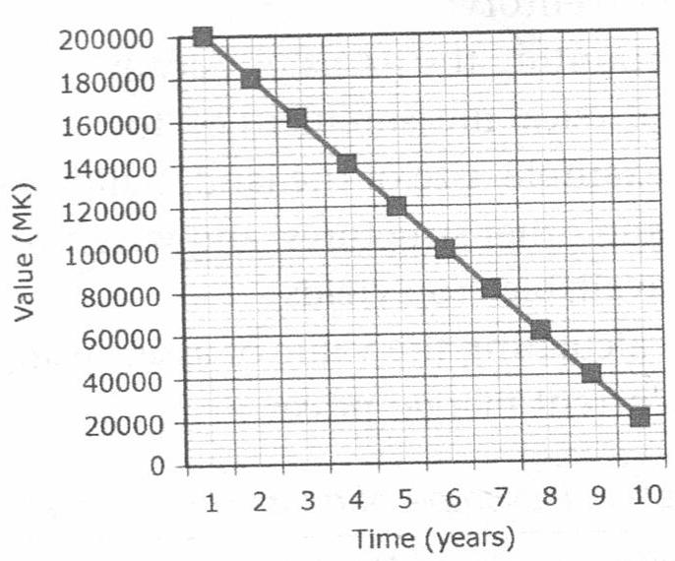 Figure 2.2: An example of straight line depreciation
- However most assets do not become entirely worthless after their expected useful life (economic life). They usually have a scrap value or disposal value which is technically called salvage value.
- Salvage value is the estimated resale value of an asset at the end of its useful life
- The farmer can still sell whatever remains as a scrap.
- The expected salvage value must be taken into account when calculating depreciation.
EXAMPLE 2
- The value of a ridger is K75000. It is expected that in 5 years the value will be K5000. Calculate the value of the ridger each year using straight line method.

SOLUTION
Depreciation = Original cost – salvage value
Life span (years)
=$\frac{75000-5000}{5}$
= K14000 per year
YEAR | VALUE DEPRECIATED | NEW VALUE /BOOK VALUE
 |  | K75000
1 | K14000 | K61000
2 | K14000 | K47000
3 | K14000 | K33000
4 | K14000 | K19000
5 | K14000 | K5000
.

DECLINING BALANCE DEPRECIATION
- In this method the amount of depreciation charged on asset declines over time.
- More depreciation is charged during the beginning of the life- time and less is charged towards the end. This is done because capital items are more productive when they are new compared to the end of their life time.
EXAMPLE
- Consider an Irrigation water pump with an original cost of MK 550,000, estimated service life of five years and salvage value of MK 50,000. Calculate depreciation using declining balance method.
Solution
Annual depreciation rate = $\frac{1}{5}$ x 100%
= 20%
YEAR | ANNUAL DEPRECIATION CALCULATION | ANNUAL DEPRECIATION CHARGE | REMAINING BOOK VALUE
0 | - | - | K550000
1 | 20% X K550000 | K110000 | K440000
2 | 20% X K440000 | K88000 | K352000
3 | 20% XK352000 | K70400 | K281600
4 | 20%XK281600 | K56320 | K225280
5 | 20%XK225280 | K45056 | K180224

NOTE: Annual Depreciation = Depreciation rate x Book value
SUM OF DIGITS
Estimate depreciation as a fraction i.e. $\frac{n}{Σ}$
Where n is the year being depreciated and Σ stands for the individual years of depreciation i.e. $\frac{n}{Σ}$(C- SV).
EXAMPLE
Given the value of a machine is K2200000. Salvage value is K200000 and economic life is 10 years. Calculate depreciation using sum of the digits method.
SOLUTION
Depreciation = $\frac{n}{Σ}$(C-SV)
Σ = 1+2+3+4+5+6+7+8+9+10
= 55

YEAR | DEPRECIATION | NET BOOK VALUE(MK)
0 | - | 2200000
1 | $\frac{10}{55}$(2200000-200000) | 1836363.64
2 | $\frac{9}{55 }$(2000000) | 1509090.91
3 | $\frac{8}{55}$(2000000) | 1218181.82
4 | $\frac{7}{55}$(2000000) | 963636.37
5 | $\frac{6}{55}$(2000000) | 745454.55
6 | $\frac{5}{55}$(2000000) | 563636.37
7 | $\frac{4}{55}$(2000000) | 418181.82
8 | $\frac{3}{55}$(2000000) | 309090.91
9 | $\frac{2}{55}$(2000000) | 236363.64
10 | $\frac{1}{55}$(2000000) | 200000.00

- Businesses need to depreciate their long-term assets because of the following seasons.
- Tax purposes of businesses use depreciation to reduce income tax of the long term assets
- Equity appraisal purposes: depreciation lowers the value of assets. This reduces the farmers equity
- Maintenance purposes: Depreciation will alert the farmer to start making arrangements ro replace specific assets in time.
PRODUCTION RECORDS
- Production records kept on the farm can be:
- Crop production records
- Livestock production records
- There are two types of crop production records namely:
- Field operation records
- Crop yield record
FIELD OPERATION RECORDS
- It is a record of crop husbandry practices (activities) carried out on each plot in the process of growing the crops.
- Farmers need to record each activity. Such information includes the date , plot , crop, name of the activity and inputs used for the activity.
- A crop diary is used for keeping a field activity record
- Separate pages should be allocated to each crop for easy access.

AN EXAMPLE OF FIELD OPERATION RECORD
DATE | PLOT NO | OPERATIONS/ACTIVITIES | INPUTS(SEED,FERTILIZERS HERBICIDES, PESTICIDES,LABOUR) | REMARKS
1/7/2014 | 1 | Land preparation | casual labour (4 people x2days) | ridging completed
10/11/14 | 1 | planting | family labour planted 10kg of PAN 77 maize | Sasakawa method was used
18/11/14 | 1 | fertilizer application (basal) | 2 x50kg bags of 23-21-0+ 4s applied by family labour | the fertilizer was inadequate
23/11/14 | 1 | first weeding | casual labour (3 people x 4 days) | work completed but soil was wet and sticky
17/12/14 | 1 | second weeding (banking) | casual labour (4 people x6 days) | took long due to interruptions due to heavy rains
27/12/14 | 1 | fertilizer application (side –dressing) | 2 x50 kg bags of urea applied by family labour | completed
17/4/15 | 1 | harvesting | casual labour (4 people x2 days) | 50 bags of 50 kg each were harvested

CROP YIELD RECORD
- It is a record of the output of the crop harvested from each plot
- It is measured in kilograms per unit area or per hectare.

TYPE OF CROP | PLOT NO | PLOT SIZE(HA) | YIELD KG | YIELD (KG /HA)
maize | 1 | 0.6 | 2458
Maize | 2 | 0.5 | 2516
Maize | 3 | 0.4 | 2387
ground nuts | 7 | 0.3 | 273
ground nuts | 11 | 0.5 | 512

An example of a crop yield record.
LIVESTOCK PRODUCTION
- This is data kept about the animals being raised on the farm.
- The type of livestock records to be kept will depend on the type of animals kept and their uses.
- Examples of livestock records include:
- Livestock number records
- Breeding records
- Dairy (milk) records
- Broiler records
- Laying records
- LIVESTOCK NUMBER RECORDS
- It is a record that shows the total number of animals on the farm at the beginning and end at the farming year.
- This includes the animals that were born, bought or slaughtered during the farming year.
AN EXAMPLE OF LIVESTOCK NUMBER RECORDS
Class of livestock | Number on hand at the beginning | Number bought or received | Number born | Total | Number slaughtered or died | Number on hand at end of farming year
Cattle | 36 | 4 | 24 | 64 | 6 | 58
Goats | 137 | 3 | 126 | 266 | 72 | 194
Sheep | 42 | 1 | 57 | 100 | 38 | 62
Pigs | 6 | 1 | 83 | 90 | 61 | 29

BREEDING RECORDS
- Key information in breeding records include:
- Oestrus cycle (date of heat) for cows
- Date of servicing (mating or artificial insemination)
- Gestation
- Date of calving /furrowing /Kidding/lambing
- Number of calves /piglets/ kids/lambs
- Calving interval /farrowing interval/kidding interval /lambing interval.
USES OF SOME BREEDING RECORDS
Items of a breeding record | purpose /use
- Date when the cow is on heat | To manage the artificial insemination program
- Date of servicing (mating or artificial insemination) | To predict the date of calving  To Prepare for the expected date of calving
- Pregnancy test results and gestation. | To cull infertile cows
- Calving dates | To monitor a cows lactation  To Identify Cows that are due to be mated
- Calving interval | To determine how long it takes a cow to calve again  To cull cows that have a long calving interval
- Number of calves per parturition | To determine the fertility rate of the cow  To cull less fertile cows

DAIRY RECORD
- This is a record of milk yield
- Good farmers keep a record of daily milk yield for each cow.
- It is important to record the amount of feed eaten each day.
MILK PRODUCTION RECORD
DATE | INPUTS USED |  |  | YIELD (KG) | REMARKS
 | FEED (KG) | MEDICINES | LABOUR (hrs)
1/2/2015 | 42 | Piperazine | 5 | 15 | Drenching
2/2/2015 | 42 | Piperazine | 5 | 15
3/2/2015 | 42 | Piperazine | 5 | 15
4/2/2015 | 42 | Piperazine | 5 | 15
5/2/2015 | 42 | Piperazine | 5 | 15
6/2/2015 | 42 | Piperazine | 5 | 15
7/2/2015 | 42 | Piperazine | 5 | 15

BEEF RECORDS
- This is a record of the amount of meat produced from the herd of cattle.
- Farmers keep a record of the type and amount of feed eaten by the beef cattle and the resulting live weight gain.
- Such a record can be used to calculate live-weight gain per week or per month or per kilogram of feed consumed.
USES OF BEEF RECORDS
ITEMS OF A BEEF RECORD | PURPOSE /USE
- Live weight and body condition of cows | - To monitor growth rate  - To Monitor the animals health
- Feed offered and feed actually eaten | - To tell if the cow lost appetite (due to sickness)  - To fine-tune the feeding program
- Animal sickness and drug treatment | - To tell if the rest of herd needs protection through isolation  - To monitor cow’s response to treatment

LAYING RECORD
- It refers to an egg production record
- The farmer can record the number of laying hens, the type and amount of feed eaten, number of eggs laid, medicines given and labour used.

EXAMPLE
DATE | INPUTS USED |  |  |  | YIELD (KG) | REMARKS
 | NUMBER OF LAYERS | FEED (KG) | MEDICINES | LABOUR (hrs)
1/05/2015 | 500 | 40 | - | 25 | 372
2/05/2015 | 500 | 40 | Lasota | 25 | 368 | vaccinated
3/05/2015 | 500 | 39 | - | 25 | 370
4/05/2015 | 500 | 40 | - | 25 | 374
5/05/2015 | 500 | 40 | - | 25 | 380
6/05/2015 | 500 | 41 | - | 25 | 376
7/05/2015 | 500 | 40 | - | 25 | 371

BROILER PRODUCTION RECORD
- A broiler production record is a record for chickens raised for meat.
AN EXAMPLE OF BROILER PRODUCTION RECORDS
Age of chickens | Number of chicks | feed type and quantity | other inputs |  | Remarks
 |  |  | Broiler medicines and vaccinations | labour
1-2 weeks (broiler chicks) | 1000 | 962 kg starter mash | - Stress pack vitamins  - Newcastle Hitchner (Avi blue)  - Gumboro (Avi blue) | 25 man days | overcrowding in a corner killed 20 chicks
3-5 wks (broilers growers) | 980 | 1455 kg growers mash | - Gumboro (AVI Blue)  - New castle (Lassota) | 25 man days | overcrowding in a corner killed 30 chicks
6-8 weeks (broiler finisher) | 950 | 1445 kg broiler finisher | - | 25 man days | sold all 950 broilers

FARM LABOUR AND ITS SOURCES
- Labour is the actual work done by people.
- Physical labour is measured in man days, hours or minutes
- Man days are measured by assessing an adult man working for 8 hours a day.
- The common assessment when coming up with man units is looking at age and sex of individuals
- It is estimated that an adult male can do 25 man days in a month (1 man day x 25)
- A female can do 2/3 of a man’s farm work (2/3 x 25) which is equal to 16.7 man days of farm work in a month. This is due to other domestic tasks society usually allocates t women.
Source of labour | Maximum amount of labour per day | Number of days in a month available for work | Total amount of labour in a month
Man | 1 man day | 25 | 25 man days
Woman | 0.7 man day | 25 | 17.5 man days
Child | 0.3 man day | 25 | 7.5 man days

- Amount of labour available from different sources on the farm is shown in the table above.
- The amount of labour supplied by an employee is affected by:
- Potential gain of doing extra work
- Physical health and diet
- Climate in hot regions people get exhausted easily
- Personal motivation
ACTIVITY

Calculate the amount of labour done for each farming operation shown in the table below
FARM ENTERPRISE | OPERATIONS | DATE | NO OF PERSONS | DAYS WORKED PER PERSON
Cattle | Dehorning | 21/11/09 | 8 men  3 women | 2  2
maize | weeding | 30/11/09 | 15 men  26 women  4 children | 2  1  1
SOLUTION

FINANCIAL RECORDS AND ACCOUNTS
- Financial records refer to written information about money paid into the farm or paid out of the farm.
- Financial records establish or prove farm income or expenditure
TYPES OF FARM ACCOUNTS
- There are three types of farm accounts namely:
- The cash book
- The trading account
- The balance sheet
THE CASH BOOK
- It is able called on income and expenditure account.
INCOME RECORD
- It is a record of the money paid into the farm.
- A record of farm income includes: Sales and receipts.
- Sales : Cash obtained after selling farm produce such as milk
- Receipts: Cash obtained (received ) for services offered by the farm such as hiring out the ox-cart to another farmer.
EXPENDITURE RECORD
- This is a record of funds paid out from the farm.
- It includes purchases and expenses
- Purchases: It is a record of funds spent for buying items such as inputs (seeds, fertilizers, pesticides, herbicides) for farm production.
- Expenses: Are records of funds paid out for services offered to the farm such as labour.
- Another type of cost that needs to be recorded is the depreciation of equipment and other assets for the enterprise.
AN EXAMPLE OF A CASH BOOK
SALES AND RECEIPTS |  |  | PURCHASES AND EXPENSES
DATE | DETAILS | TOTAL (MK) | DATE | DETAILS | TOTAL(MK)
01/06/08 | opening balance  cash at bank | 1,025,000 | 18/08/08 | 20kg maize seed | 4,000
23/08/08 | 25000kg | 1,300,000 | 29/09/08 | 1000kg fertilizer | 92,000
17/09/08 | 100 units eggs | 75,000 | 12/10/08 | 3000kg feeds | 300,000
30/03/09 | 500kg beef | 300,000 | 03/01/09 | 200kg layers mash | 20,000
05/04/09 | 1200kg milk | 600,000 | 26/03/09 | 520 sacks | 26,000
21/05/09 | 1000kg beans | 160,000 | 02/04/09 | 4kg actellic dust | 4,000
 |  | 3,460,000 |  |  | 446,000
 |  |  | 31/05/09 | closing balance cash at bank | 3,014,000
 |  | 3,460,000 |  |  | 3,460,000

TRADING ACCOUNT
- It is also called a profit and loss account
- Trading means buying and selling
- A trading account for a farm or an enterprise is a detailed record of items bought (expenditure) for the farm business and items sold (income) from the farm business.
- Determination of the value of the farm’s assets at the beginning of the farming year is called opening valuation. On the other hand, determination of the farming year is called closing valuation.
- On the other hand Trading account takes into account depreciation of an asset and labour.
- The mathematics difference between opening valuation and closing valuation represents a gain or loss in the value of the assets.
EXAMPLE
- A trading account takes into account the following information:
- Opening valuation : Crops in the field = Mk 185,000.00
Livestock = 374000.00
Produce in store = 61500.00
Inputs in store = 86400.00
K706 900.00
- Closing valuation : Crops in the field = Mk 79000.00
Livestock = 408000.00
Produce in store = 26000.00
Inputs in store = 15000.00
= 528000.00
- Depreciation : Buildings = Mk 28600.00
Machinery = 107500.00
= 136100.00

Labour = Mk 249000.00

SALES AND RECEIPTS |  |  | PURCHASES AND EXPENSES
DATE | DETAILS | TOTAL (MK) | DATE | DETAILS | TOTAL(MK)
23/08/08 | 25000 kg maize | 1300 000 | 01/06/08 | opening valuation | 706 900
17/09/08 | 100 units eggs | 75000 | 18/08/08 | 20kg maize seed | 40000
30/03/09 | 500kg beef | 300000 | 29/09/08 | 1000kg fertilizer | 92000
05/04/09 | 1200kg milk | 600000 | 12/10/08 | 3000kg concentrates | 300000
21/05/09 | 1000kg beans | 160000 | 26/03/09 | 200kg layers mash | 20000
31/05/09 | closing valuation | 528000 | 26/04/09  10/04/09 | 4g Actellic dust  520 sacks | 4000  26000
 |  | 2963000 |  |  | 1188900
 |  |  |  | Labour  Depreciation | 249000  136100
 |  |  |  | Profit | 1389000
 |  | 2963000 |  |  | 296300

DEBTORS AND CREDITORS
- Debtors are borrowers people or organizations who owe the farm money
- Creditors one people or organizations owed money by the farm.
THE BALANCE SHEET
- A balance sheet is a statement of all the asset and liabilities of the farm business at a specific time
- It shows the net value or net capital of the farm
- Such a net value will show if the farm is solvent or in deficit.
EXAMPLE
LIABILITIES | MK | ASSETS | MK
Bank loan | 4,000,000 | cash in hand | 20000
bank overdraft | 50,000 | cash at bank | 1,870,000
interest payable | 800,000 | debt receivable | 60,000
Debt payable | 10,000 | Truck value  Tractor value | 2500,000  4 930,000
 | 4,800,000 | value of buildings | 1500 000
Net capital | 9720 000 | value of land | 3010 000
 |  | value of livestock | 500 000
 |  | Value of crops | 190 000
 | 14580 000 |  | 1458 000

TOPIC 5: FARM BUDGETING
- Budget is an itemized summary of future (expected) income and expenditure of a farm or any business over a specified period , usually a year
- Farm budgeting is a process of working out the expected income and expenditure for an agricultural enterprise in a given period.
- Farming as a business aims of making a profit.
TYPES OF FARM BUDGETS
- There are three types of farm budgets namely:
  - Partially budget
  - Complete budget
  - Break –even budget
PARTIAL BUDGET
- A partial budget is a type of budget that affects only part of the farming system.
- A partial budget affects only part of the farming system.
- It is used to evaluate a small change in the farming system.
USES OF A PARTIAL BUDGET
- A partial budget would be useful when the farmer wants to:
- Expand the existing enterprise or make additions to existing enterprises
- For example, the farmer may want to increase the area for crops or increase the number of livestock for dairy, beef, broiler or egg production.
- Change one enterprise for another
- This is called substitution, substitution can either be in part or whole
- Introduce a new enterprise
- In this case the farmer can introduce one enterprise without necessarily changing other enterprises.
- Buy a new farm machinery
- Adopt a change in method of production.
- For example, introducing the use of a machine to shell groundnuts or maize instead of shelling by hand.
EXAMPLE OF A PARTIAL BUDGET
- Kupilira farm in Dedza wants to eliminate potato production (l0ha) and substitute it with cabbages (l0ha). Two labourers are to be laid off in the process. Given the following information prepare or partial budget for the farm and advise the manager accordingly.
Potatoes
- Yield is 35 tonnes /ha
- Selling price is K2000/tone
Production costs:
- Seed 2.5 tonnes /ha at K1000/tone
- Marketing transportation K5000
- One person’s labour charge K1000
Cabbages
- Expected yield is 20 tonnes per ha
- Expected selling price is K5000/tone
Production costs:
- Seed required is 7 kg selling at K250/kg
- Fertilizer required is 1000kg selling at K2000/50kg bag
- Pesticide and herbicides cost K400/ha
Solution

Partial budget for Kupilira farm
COSTS CHANGE | BENEFITS OF CHANGE
New costs Mk  seed 250 x7 = 1750  Fertilizer (1000/50) X 2000 = 40000  Pesticide and Herbicides 400 X10 = 4000 | New revenue MK  cabbage sells 20x10x 5000 = 1000 000
OLD Revenue  potato sells 35 x 10 x 2000 = 700 000 | Old costs  seed 2.5 x 10 x 1000 = 25000  marketing 1x 5000 = 5000  2 x 1000 = 2000
745 750 | 1,032, 000
Additional income 286 250 | B-A
1,032 000 | 1,032, 000

The farmer should adopt the new enterprise since it is profitable.
ACTIVITY
Mr Kamuzingeni has 2 hectares of land on which he grows SC627 maize. He however intends to make the following changes:
- To sell 50 bags of maize at K4000/ bag to Chibuku Company instead of K3000/ bag to ADMARC
- TO SPEND K3000 instead of K600 on actellic.
- To send K5000 per hectare instead of K2000 per hectare on casual labour.
- To store maize in 50 sacks at K100 each instead of storing in the nkhokwe.
- To apply 4 bags of Urea instead of 6 bags per hectare at K15000/ bag.
- Prepare a partial budget for Mr Kamuzingeni.
- How would you advise the farmer?
COMPLETE BUDGET
- It is the type of farm budget that affects the whole farming system.
A Complete budget is prepared when a farmer:
- Is opening a new farm
- Intends to carry out a major re-organisation of the farming system.
STEPS A FARMER SHOULD FOLLOW WHEN PREPARING A COMPLETE BUDGET.
- Make an estimate of what is possible to produce, bearing I mind limiting factors to production
- Estimate the expected yield of crops and output from animals.
- Estimate the input requirements for both crop and animal production.
- Estimate the expected prices of crops and animal output and costs in inputs (variable costs)
- Estimate the cost of permanent labour, machinery and equipment (fixed costs)
- Estimate other costs e.g. depreciation of building and equipment
- Calculate the total costs, total returns and profit from the plan.
NOTE
- Gross margin refers to the amount of money that is left after the variable costs are subtracted from the output (yield or income)
- Gross margin is not the same as profit, as fixed costs are not taken into account.
- To get a complete budget, subtract fixed costs from the total gross margins for the various crop and animal enterprises. This will give an indication of the net profit.
- Variable costs are those that change in proportion to the size of the farm.
- Examples of variable costs include cost of seeds, fertilizers, livestock feeds and drugs, casual (hired) labourers
- Fixed costs are those that do not necessarily change with the size of enterprise.
- Examples of fixed costs include depreciation of farm buildings and machinery, cost of permanent labour, costs of maintaining farm building or machinery.
- Variable costs are used to calculate gross margin i.e. Total revenue minus variable cost.
- Fixed costs are used to calculate profit i.e. gross margin minus fixed costs.
- Gross margin = Total Revenue – Variable costs GM= TR –TVC
- Profit or loss = Total Revenue – Total costs
i.e. profit or loss = TR-TC, TC = TFC + TVC
or profit = TR – (TFC + TVC)
or Profit = GM-TFC

EXAMPLE
Mrs Makungwa grows 3 ha of groundnuts and keeps the following records.
- 8 hoes at K8.00 each
- Groundnuts seed : K90.00
- Hiring an ox-cart to the market for the sale of the nuts : K75.00
- Casual labourers : 5 people at K30.00 each per month for 4 months.
- Permanent labourers : 3 people at K300.00 for 4 months
- Cost of chemical spray : K25.00
- Cost of sprayer : K60.00
- Output : 2000 kg/ha
- Price for shelled nuts : K0.90/kg
- Sale of groundnuts remains to livestock farmer: K100.00
- Calculate the gross margin and profit for Mrs Makungwa
Solution
    - Total Revenue: = 2000kg/ha x 3 ha x K0.90 /Kg + K100.00 = K5500
    - Variable costs:
Seed = K90.00
Hiring of ox-cart = K75.00
Casual labour = 5 x4 x 30 = K600.00
Chemicals = K25.00
Total variable costs = K790.00

    - Fixed costs:
8 hoes @ K8.00 each = K64.00
Permanent labour = K300.00
Cost of sprayer = K60.00
Total fixed costs = K424.00

Gross margin = TR – TVC
= K5500 – K790
K4710
Profit = GM –TFC
= K4710-K424.00
=K4286.00
Or Profit = TR-TC
=TR – (TFC + K TVC)
=K5500= (K424 + 790)
= K5500 – K1214
= K4286.00
b) Why is it better for the farmer to be calculating gross margin other than profit?
- Because with gross margin one just considers the expenditure faced in that particular growing season. Fixed inputs (costs) will always be there every year.
BREAK-EVEN BUDGET
- A break-even budget indicates the level of production (or price) at which the business unit makes neither a profit nor a loss.
- In other words it is a farm budget where total Revenue (TR) is equal to total cost (TC)
- This is represented as:
TR= TC
TR= Price per kg x quantity of produce
TC = Fixed costs + variable costs, i.e. TC= FC + VC
BREAK EVEN CHART

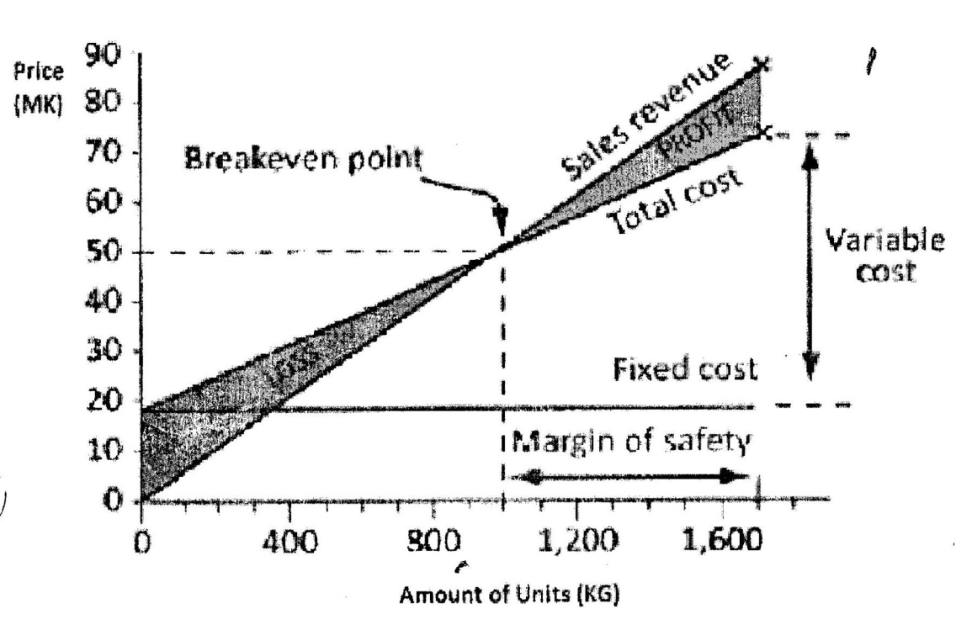
Figure 2.3: Breakeven chart
- Break even analysis: Is the analysis used to determine the point at which revenue received equals the costs.
- Margin of safety is the amount that revenue exceeds the breakeven point
- Break even yield: Is the level of yield at which the farmer will neither make a profit nor loss.
- Breakeven price is the price at which revenue is equal to total cost.
- Breakeven point is the point at which total revenue is equal to total cost
CALCULATING BREAK EVEN YIELD AND BREAK EVEN PRICE
EXAMPLE 1
i.Mr Phiri wants to engage in wheat production and is expected to use K 186140. He anticipates selling the wheat at MK 275/kg. Calculate the break even yield for wheat.

Solution
Break even yield = Total cost = K186140 x 1 kg
Output Price K275

= 676.87 kg
ii. What can be the break even yield if the price increases to K 412
per kg?

Solution
Break –even yield = 186140 = 451.8 kg
412

EXAMPLE 2
Mr. Phiri wants to engage in wheat production and is expected to use K 186 140. If the expected yield for wheat was 75 kg. Calculate the break –even price.

Solution
Break – even price = Total cost
Expected yield

= Mk 186 140
75 kg

= K2481.87/Kg
NOTE
Breakeven price decreases with increase in yield or production.

TOPIC 6: ECONOMIC PRINCIPLES FOR DECISION MAKING IN AGRICULTURE
DECISION MAKING ON THE FARM
- Farmers make decision in order to solve farming problems.
- They use economic principles/economic theories in order to come up with the most suitable decisions.
- These economic principles include:
- Opportunity cost
- Comparative advantage
- Substitution of inputs
- Diminishing marginal returns
OPPORTUNITY COST
- It refers to the next best alternative to an action
- For instance, consider a farmer who had the following priority list of possible enterprises for his farm:
- Paprika
- Soya beans
- Cotton
- Groundnuts
- On this scale of preference, the farmer is likely to decide to grow Paprika
- In this case, the next best alternative available is the soya beans (that is the opportunity cost of growing Paprika).
- Opportunity cost can also be defined as the return that is given up.
- For example, a farmer who is growing 2 ha of tobacco and 1 ha of maize. Due to falling prices for tobacco in a particular year, the farmer wants to increase maize production by 1 ha and reduce the hectares of tobacco by 1 ha. Therefore, the opportunity cost is the income from the yield that would have been obtained from the 1 ha of tobacco that has been given up.
DETERMINATION OF OPPORTUNITY COST
- Consider the following three questions when making decisions on the farm:
- What alternative opportunities are there?
- The farmer has to make a list of the different possible opportunities available to him.
- What is the best of these alternative opportunities?
- The farmer compares the different opportunities through measurements such as monetary value, quantity in kg, time saved etc.
- What benefit would I get if I selected the next –best opportunity instead of the choice I am settling now?
- Or what am I losing by settling on his choice instead of the next best opportunity?

IMPORTANCE OF THE THEORY /PRINCIPLE OF OPPORTUNITY COST
- Choosing wisely: The farmer is guided to make rational choice.
- Evaluating options: Farmers assess the options before making the final decision.
- Efficient use of scarce resources
- Farmers make the best land, labour, capital and even management.
- Maximizing satisfaction: Farmers select the alternative that can give them the maximum benefit/profit
THE PRINCIPLE OF COMPARATIVE ADVANTAGE
- It states that farmers, districts, regions or countries should concentrate on products in which they have greater relative advantage compared to others.
- Relative advantage for a farmer may be due to favourable soils, climate, expertise or nearness to a market.
- One village, one product (OVOP) programme applies the principle of comparative advantage.
- OVOP seeks to encourage farmers in each area/village to select atleast one product suited to their area such as groundnuts, concentrate on it, produce it using their local resources, and then offer it to the market, trading, nationally or internationally.
THE PRINCIPLE OF SUBSTITUTION OF INPUTS
- It states that it is beneficial for a farmer to replace (substitutes)an input, resource, technology for another if it:
  - Reduces costs (it is cheaper) but produces the same yield or
  - Has the same cost, but increases yield.
- A farmer’s choice of an input for substitution depends on the prices of the various inputs he might use.
- Examples of input substitution include the following :
- Weeding by hoeing out the weeds or by spraying herbicides.
- Feeding layers on a commercial ration or a home mix.
IMPORTANCE OF THE RINCIPLE OF SUBSTITUTION OF INPUTS
- It helps the farmer in choosing the cheaper or more profitable inputs, resources or technology of production.
- The principle also helps the farmer to answer the farm management question of how to produce?
DIMINISHING MARGINAL RETURNS
- The principle of diminishing marginal returns states that an increase in one input (when other resources are held constant) will increase output, but after a point, the extra output resulting from the additional input, will be less

DIMINISHING MARGINAL RETURNS
Stage of marginal returns | Amount of seed kg/ha | Marginal yield kg/ha
Increasing marginal returns | 0 | 0
 | 1 | 11
 | 2 | 20
 | 3 | 22
Diminishing marginal returns | 4 | 19
 | 5 | 13
 | 6 | 7
Negative marginal returns | 7 | -1
 | 8 | -8

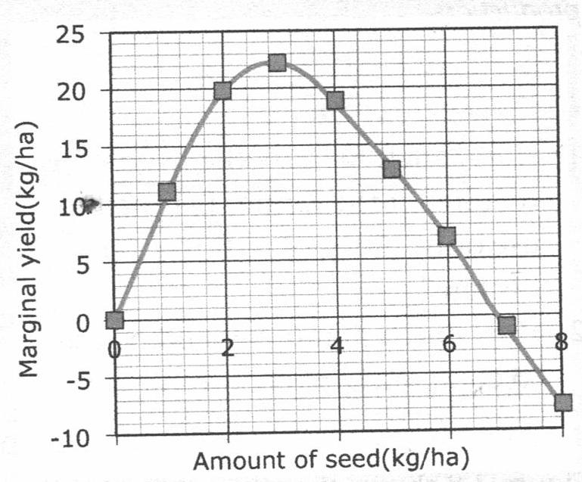Figure 13: Diminishing marginal returns.
ITERPRETATION OF THE PRINCIPLE OF DIMINISHING MARGINAL RETURNS
- There are three stages of the law of diminishing marginal returns.
- The stage of increasing marginal returns.
- This occurs from S=0, Y=0 to S=3, Y=22.
- In this stage, the additional input causes the marginal output to rise.
- The plants grow vigorously and produce without much limitation or competition.
- Stage of diminishing marginal returns.
- This occurs from S=3, Y=22 to S=7, Y=0
- In this stage, the additional input causes the marginal output to lessen (but still positive).
- In this stage, the plant population is becoming greater and greater.
- As more and more seed is added, the competition between plants for the fixed resource (land, space, nutrients, oxygen, light etc) become higher, since the fixed resources one becoming inadequate for the additional seed input, resulting in lowering the marginal yield.
- Stage of negative returns
- This occurs from S=7, Y=0.
- This stage starts when the additional input (seed) becomes too excessive compared to fixed resources, causing the marginal output to be less than zero (negative).
- The plants may develop deficiency diseases, shade one another or even suffocate.
IMPORTANCE OF THE PRINCIPLE OF DIMINISHING MARGINAL RETURNS IN DECISION MAKING
- It helps the farmer to:
- Understand the relationship between level of input and level of production so that the farmer can decide on the best level of input to use for optimum production.
- Identify the point (stage) when diminishing returns set-in.
- Avoid waste of farming resources.
- Understand that there is a point or stage where benefits of doing something will slowly diminish.
- Understand that spending and investing more and more in a product where other factors remain constant, the returns will begin to diminish in the long run
- Deal with increasing marginal costs that would otherwise arise from increasing level of inputs.
TOPIC 7: ENTERPRISE COMBINATIONS
- A farm enterprise is a single type of crop or livestock that produces a marketable product.
- Some examples of farm enterprises in Malawi are
- Goat farming
- Cassava farming
- Banana production
- Mushroom production
- Dairy farming
- Enterprise combination refers to the practice of carrying out two or more enterprises on the farm.
- A farmer can decide to have two or more enterprises, such a combination of farm enterprises can be made up of:
- Crop enterprises only
- Livestock enterprises only
- Crop and livestock enterprises
- Enterprise can be combined because of their capacity to benefits each other or to benefit the farmer.
CLASSIFICATION OF ENTERPRISES
- Enterprise are classified into 3 categories
- Production enterprise – such as maize, beef, or poultry farming that produce a marketable product
- Service enterprises – such as tractors, combine harvester that offer services to production enterprises.
- Holding enterprises – such as storage, capital and warehouse that holds input and produce until they are used on a service enterprise or production enterprise.
FACTORS TO CONSIDER WHEN SELECTING ENTERPRISE COMBINATIONS
- Profitability of the enterprises
- Decision on enterprise combinations should consider the contribution of each enterprise to the overall profitability of the farm.
- The availability of farming resources.
- When combining enterprises the farmer needs to have enough land, adequate labour, enough capital and managerial skills.
- The food requirements of the farming family
- The farmer should spare first food crop production before consideration is given to cash crops to meet the family’s food requirements.
- Statistics show that:
- An adult will require an average 300kg of maize per year.
- A young person (under 18 years) will require 150kg of maize per year.
- Risks and uncertainty
- Farmers should insure their enterprises in order to claim compensation from insurance companies in the event of theft, fire or loss of farm assets and produce.
- Changes in prices
- A good farmer is always on the look-out for price changes for farm products.
- Prices may fall or increase.
- Changes in technology
- Farmers need to evaluate the benefits of a new technology before adopting it in enterprise combination.
- Crop rotation.
- Farmers should aim at improving soil fertility and reducing pests and diseases through crop rotation when combining enterprises.
TYPES OF ENTERPRISE COMBINATIONS
There are 3 types of enterprise combinations namely;
- Competitive enterprises
- Supplementary enterprises
- Complementary
COMPETITIVE ENTERPRISES
- This is where an increase in one enterprise results in a decrease in the other enterprise.
- For instance, a farmer may have 10 hectares of land which is appropriate for a combination of maize and sorghum.
- If more of either maize or sorghum is planted, the output of the other declines. This is because the two enterprises are competing for the same resources (land).
- When enterprises are competitive, three things determine the exact combination for them to be profitable:
- The cost of producing the product
- Price of the product
- The rate at which one product substitutes for the other.

COMPLEMENTARY ENTERPRISES
- An increase in one product (enterprise) may increase the total production of the other through beneficial effects.
- For example, poultry and vegetable production are complementary.
- The manure from poultry helps to increase vegetable production by providing essential plant nutrients; while the vegetables can be fed to chickens as green feed to provide minerals and vitamins.
- Duck and fish farming is also an example of complementary enterprise.
SUPPLEMENTARY ENTERPRISES
- This is where an increase in one product does not affect the other, but adds to the total income of the farm.
- For example, a farmer having sufficient land and family labour, grows maize in the rainy season, in the dry season, he may decide to make use of the idle land and labour by growing vegetables such as tomatoes.
- The two enterprises neither help nor hinder each other.

TOPIC 8:
AGRICULTURAL COOPERATIVES
- A cooperative is a group of people who have come together on a voluntary basis for the purpose of a common goal for mutual benefit.
- Agricultural cooperative is an organization formed by a group of farmers (ten or more), who join together to pool their resources and services to achieve a common goal.
IMPORTANCE OF AGRICULTURAL COOPERATIVES
They help farmers to:
- Secure loans from commercial banks.
- Transport their produce to markets more easily.
- Bargain for better prices or selling conditions as a group.
- Buy inputs cheaply since the society is able to buy these in bulk and at wholesale prices.
- Quickly adopt innovations in agriculture by sharing expertise and knowledge.
- Make use of expensive machinery such as tractors.
- Take advantage of storage and processing facilities by sharing these.
PRINCIPLES FOR THE FORMATION OF AGRICULTURAL COOPERATIVES
- There are seven principles that were agreed by the International Cooperative Alliance (ICA) in 1995.
- A cooperative should be legally constituted, with guiding rules or regulations.
- Participation is voluntary. People are free to join or withdraw.
- Cooperatives are impartial and not based on political or religious grounds.
- A cooperative is open to all farming community members who share a common interest.
- Cooperatives are organized and run according to democratic principles (one person, one vote).
- A committee of up to ten members is democratically elected i.e. Chairperson, Secretary, Treasurer and Committee members.
- The election of members is based on trust and quality leadership skills.
FORMATION OF COOPERATIVES
- The formation of cooperatives is completed in five stages.
- 10 or more farmers show interest to form a cooperative.
- The group members express interest to the Director of cooperatives.
- The interested group is trained in philosophy and principles of cooperatives.
- Steering committee meetings responsibilities such as:
- Writing a business plan
- Drafting by-laws
- Conducting financial analysis
- The cooperative is registered with a resistor of cooperative.
- The following are required when registering a cooperative in Malawi:
- Application letter (form A) to registrar of cooperatives including list of board of directors.
- Three copies of by-laws
- Minutes of meeting authorizing registration
- Registration fees as may be applicable at that time.
MANAGEMENT OF COOPERATIVE
- Members elect a board to oversee the cooperative in terms of policy
- A manager and other staff are employed to run the cooperative.
- The management team is responsible for finance, production and marketing.
- Below is the structure and management of a cooperative society.
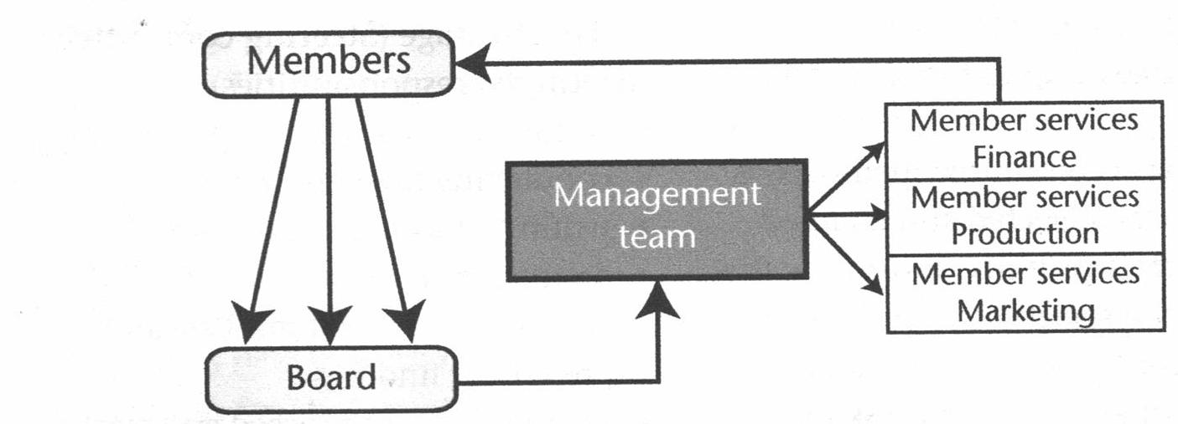
Figure 2.4: Structure and management of a cooperative society.
CHALLENGES OF RUNNING AGRICULTURAL COOPERATIVES
- Lack of infrastructure, equipment, transport
- Lack of motivation and expertise among managers and staff.
- Lack of social responsibility and lack of self-help spirit.
- Lack of equity and equality among members.
- Poor leadership and management
- Leaders elected should be democratic, transparent and accountable.
- Lack of capital
SOLUTIONS TO THE CHALLENGES FACED BY AGRICULTURAL COOPERATIVES.
- Providing enough funds through membership fees and getting loans from banks.
- Constructing necessary infrastructures and purchasing equipment and vehicles.
- Choosing reliable, honest, trustworthy and transparent leaders.
- Proper supervision of the employed managers and other staff.
- Ensuring that there is equal employment and participation among male and female
- Employing staff with skills and expertise in accounting, book-keeping and business management.
- Cultivating and encouraging the spirit of self-help and social responsibility among members.
- Training members, board members and management teams on cooperative management and planning.

TOPIC 9: VEGETATIVE PLANTING MATERIALS
- This refers to the production of new plants by using part or parts of an existing plant, without the use of seeds.
- It is also called asexual propagation.
- Only one plant is involved and the offspring is the result of one parent.
- Vegetative planting materials are parts or plants that are used to produce new plants.
COMMON VEGETATIVE PLANTING MATERIALS USED IN MALAWI
- STEM CUTTINGS
- These are pieces of stem that have buds at each node and develop adventitious roots.
- The stem cuttings of sugarcane, napier (elephant grass) and cassava are used for propagating these crops.
PROPAGATING SUGARCANE
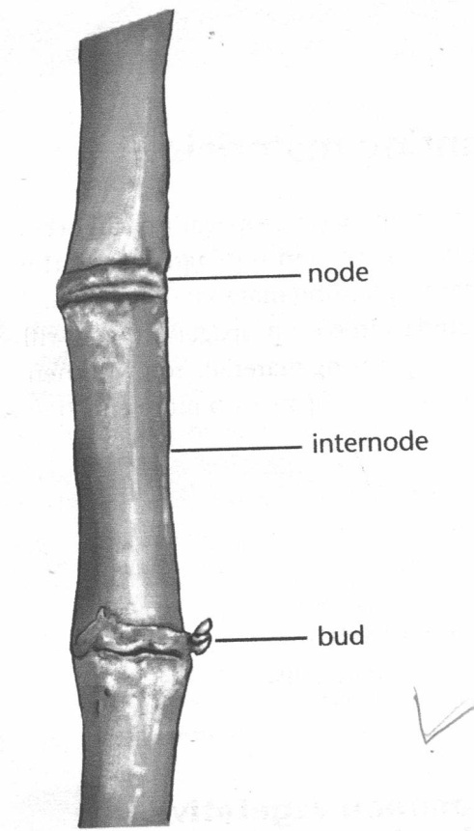
Figure 2.5: A Sugar cane cutting
- Select the freshest uppermost parts of sugarcane plants.
- Cut them into lengths of about 15-30cm using a panga knife.
- The cuttings are called seed pieces/setts.
- Each cutting should have about 3 nodes. Each node has a bud.
- Use three node cuttings for planting in order to obtain:
- High germination capacity
- High initial plant vigour of the germinated roots.
- High sugarcane yield
- A shoot system develops from the bud. The node produces roots. The roots develop from all around the base.
- The middle bud in a three – node cutting has the highest germination capacity because its moisture resources are better protected by nodes on either side, than those of the buds at either end.
- Germination capacity of single – node cutting is very poor due to loss of moisture from the ends of the cutting.
- The plants arising from single – node cuttings also lack vigour and have low yield.
- Always use fresh, genetically pure, pest and disease free cuttings as seed material.
PROPAGATING CASSAVA
- Cassava cuttings for planting should be free from insect pests such as cassava mealy bug and cassava scales and diseases such as cassava mosaic virus.
- Cuttings should be obtained from the base to the middle portion of mature plants.
- Each cutting should be 25-30 cm long.
- Stem cuttings can also be used to propagate plums, grapes, hibiscus, tea, carnations, blackberries etc.
- RUNNERS
- A runner is a stem which grows horizontally above the ground.
- As a planting material, the piece must have nodes.
- Strawberries, sweet potatoes and many pasture grasses such as Henry Henderson Star grass are propagated in this way.
- STEM TUBERS
- A stem tuber is the underground swollen portion of the stem.
- It acts as a storage organ.
- The Irish potato is a stem tuber.
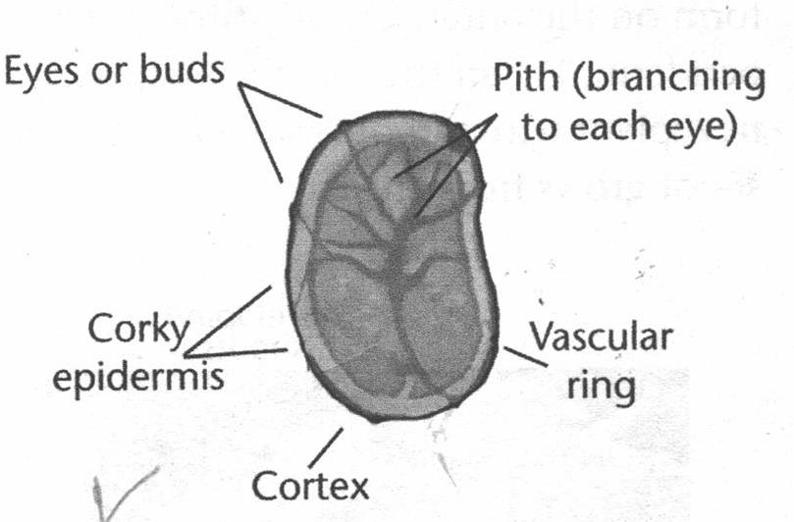Figure 2.6: A cross section of a potato tuber.
- The part of the stem tuber representing the node is called the eye (undeveloped bud)
- The eyes are the growing points where the new plants will emerge.
- The tuber is a modified stem with lateral branches forming the potato eyes.
- The potato tuber has several eyes (buds).
- The eyes are arranged around the tuber in the form of a spiral.
- The interior of the tuber shows a pithy central core with branches leading to each of the eyes.
- Surrounding the pith is the parenchyma where starch is deposited for storage.
- Towards the outer part of the tuber is the vascular ring. It contains the cambium and the outer cortex that contains the pigment that colours the skin of some varieties e.g. brown, red, pink and purple.
- The potato skin (periderm) is a layer composed mostly of cork.
- Scales form on the outer surface of the periderm.
- When the tuber is planted, a new plant with a root system and a shoot grows from the eye.
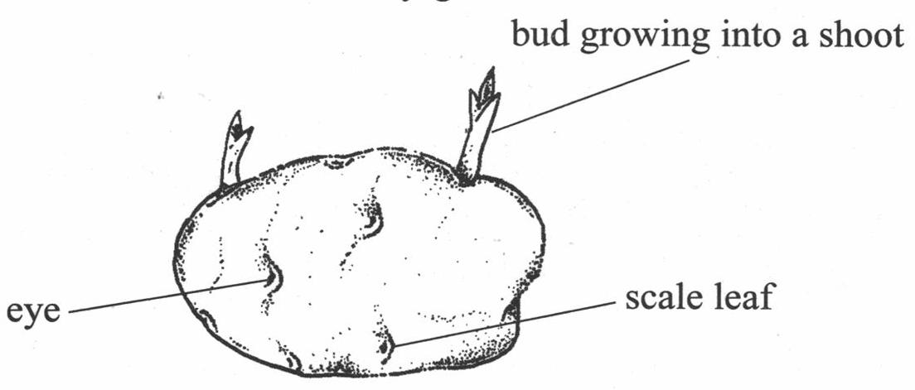Figure 2.7: Irish Potato Tuber
- SUCKERS
- A sucker is a shoot (tiller) arising from an axillary bud at the base of a parent plant.
- This is the only way of propagating bananas, plantains and pineapples.
- Choose suckers from vigorous plants.
- The suckers should have small, spear shaped leaves and ideally be about 1m high.
- Small suckers take longer to fruit and the first bunch will be small.
- Suckers are separated from the main plant by cutting with a hoe or a shovel.
- Get a big part of the corm since it contains many roots.
- BULBS
- A bulb is the flattened stem with nodes bearing fleshly scale leaves surrounded by some dry scale leaves.
- Buds arise from the axils of the fleshy scale leaves.
- Food is stored in the fleshy scale leaves.
- At the centre of the bulb is an apical bud. This produces leaves and flowers.
- Lateral buds develop in the axils of the leaves that make up the bulb. Hence, they are also called axillary buds. New shoots develop from the axillary buds.
- The new shoot gets food in the fleshy leaves or the bulk.
- Onions, tulips, lilies and garlic can be propagated through bulbs.

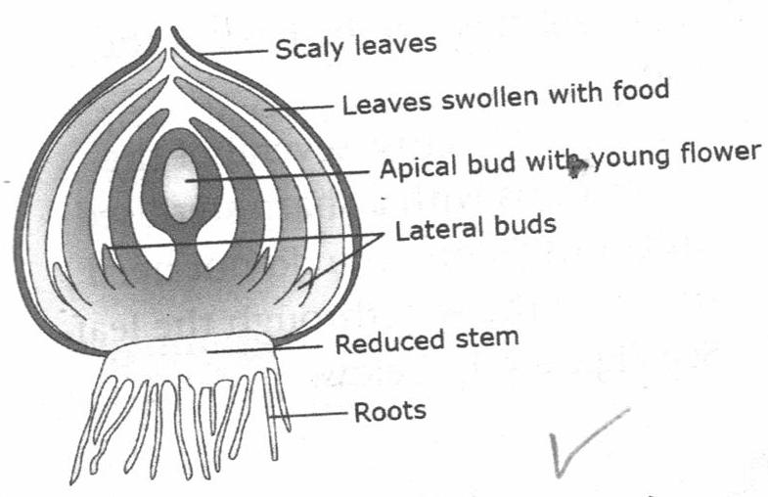
Figure 2.8: An Onion Bulb for vegetative propagation
- CORMS
- A corm is a thickened base of an underground stem in which food is stored.
- A new shoot develops from the bud on the side of the parent corm.
- The new shoot gets its nutrients from the food stored in the parent corm.
- The corm is protected by dry scale leaves.
- Cocoyam can be propagated using corms
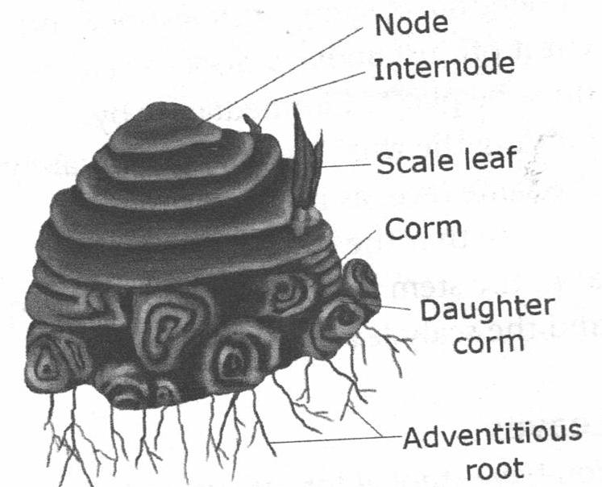
Figure 2.9: A Corm

g. RHIZOMES
- A rhizome is a think, horizontal underground stem.
- The leaves are reduced to thin scales.
- New shoots and roots grow from the buds on the rhizome.
- In some plants, adventitious roots are present.
- Ginger, bamboo and bananas can be propagated using rhizomes.
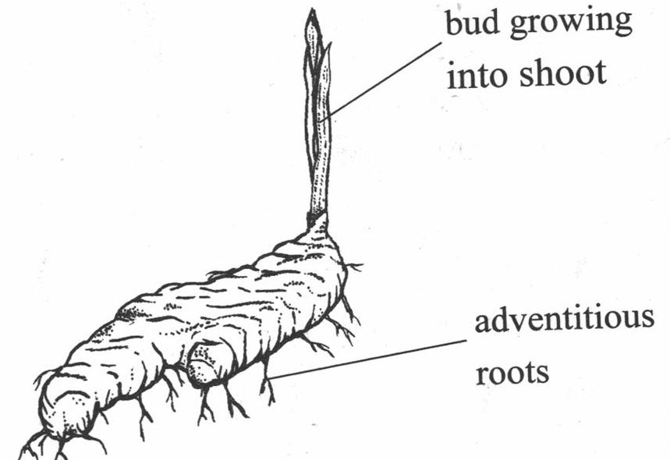Figure 3.0: Rhizome
h. LEAVES
- Leaves which have prominent net veins can be used as vegetative planting materials.
- The leaves should also be thick since they contain a lot of stored food.
- Begonias, African violets, cactus plants and air plants can be propagated using leaves.
- Leaves of plants like begonias will root along the veins when the leaf is held the soil
- Cut the main vein to promote roofing at these points.
STEPS TO BE FOLLOWED WHEN PROPAGATING PLANTS USING LEAVES
- Water the plant before collecting the leaf to ensure high cell turgidity.
- Select a healthy, mature succulent (Juicy) leaf from the parent plant.
- Remove the petiole (leafstalk) with a sharp knife.
- Cut the leaf across several of the larger veins with a sharp sterilized knife or scissors.
- Dust the cut veins with a rooting hormone ( encourages the production of new roots)
- Place the prepared leaf into a pot filled with damp soil while the leaf cutting is still fresh.
- Pin the leaf flat, bottom-side-down, to the surface of soil using thorns or toothpicks to ensure the leaf stay contact with the moist soil at all times.
- Place the pot with the cutting into a transparent plastic bag.
- The bag provides humidity to prevent wilting of the leaf cutting.
- The bag also allows the leaf cutting to get sunlight for photosynthesis.
- Water the cutting while still inside the bag.
- Remove the cutting from the bag when you see new leaves or shoots beginning to form.
- When each of the shoots has two sets of leaves, separate the new shoots by cutting the leaf apart with a knife.
- Transport each of the new plants into separate small pots or polythene tubes filled with soil.
LAYERING
- This involves pegging down the ground a branch of a tree so that it can develop roots for a new shoot while still attached to the plant.
- It also involves covering a branch of the wounded plant at the wound with soil, so that it develops roots at the injury plant while it is still attached to the parent plant.
- If a branch is low and can be bent to the ground, layer it by burying the wounded part in the soil. It develops roots and shoot on the wounded part. This is referred to as simple layering.

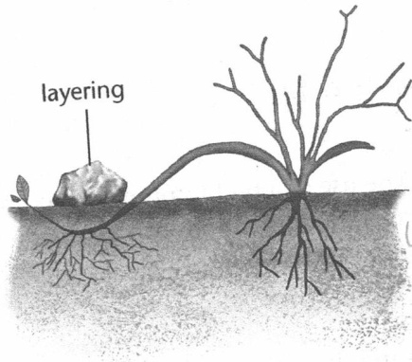
Figure 3.1: Simple layering
- If the branch cannot be bent to the ground, layer it by wrapping the wound with moistened soil and tie both ends with rubber bands. This is called air layering.

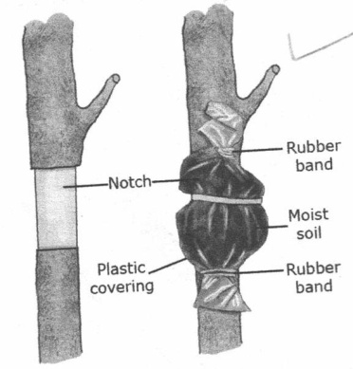
Figure 3.2: Air layering
- Fruits trees such as guavas or apples can be propagated through layering.
BUDDING
- A bud from one plant is transferred and, joined to the stem of another plant where it develops into a new shoot.
- A bud is carefully sliced off the branch of one tree.
- A patch or a T- shaped cut is made on the stem of another tree.
- The bud is carefully inserted into this cut and tied with a string.
- After the bud has healed, the top of the stock is cut off above the bud, thus forcing the new bud to grow.
- The use of buds to propagate crops is called budding.
- Roses can be propagated using buds.

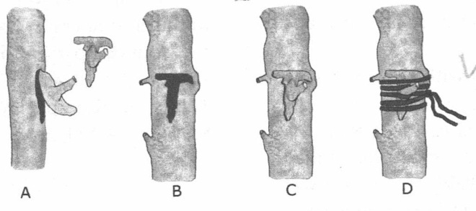Figure 3.3: T- Budding
GRAFTING
- It involves joining a part of one plant called a shoot or scion onto the stem of another plant that has roots called a stock (root stock).
- The two parts must be from the same species and must have the some thickness.
- The union must ensure that the cambium layers matched. The cut can be a slant or V-shaped.
- The Union must be neatly fitted and tapped or bound –up with a string.
- Crops that can be grafted include mangoes, all citrus fruits trees, apples and avocado pears.
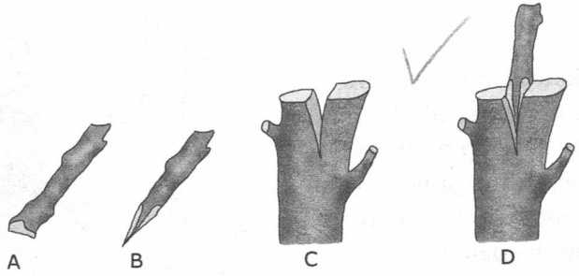Figure 3.4: Cleft grafting
IMPORTANCE OF GRAFTING AND BUDDING
- The use of winter –hardy roots on desired plants to extend their range of growth.
- The use of disease or insect-resistant roots on desired cultivars to reduce losses in the landscape.
- To help in creating dwarf crops that can withstand lodging.
- It allows different varieties of a fruit crop such as mangoes to grow from the same tree.
ADVANTAGES OF VEGETATIVE PROPAGATION
- Crops originating from vegetative materials mature faster than those from seeds.
- Facilitates propagation of plants with low seed viability
- They germinate faster compared to seeds because they do not become dormant.
- It ensures genetic uniformity and purity since new plants resemble their parents
- Vegetative planting materials are reading available to the farmer from the previous crops, hence eliminating the need to buy seed each growing season.
- Vegetative organs are more hardy than seedlings from seeds hence they are able to withstand environmental hazards in the field such as drought
- The desired trait (character or quality) of a plant is automatically preserved when vegetative planting materials is used.

DISADVANTAGES OF VEGETATIVE PROPAGATION
- Materials are bulky hence difficult to store and transport
- Materials cannot be stored for long since they get spoiled easily.
- It does not result in new crop varieties
- The risk of transferring diseases to new plants is high since the offspring inherits all the characteristics of the parent.
- Some techniques in vegetative propagation like grafting, layering and budding require specialist knowledge and skills.
- It is slow and tedious to collect, prepare and plant the vegetative planting materials.

TOPIC 10: CROPPING SYSTEMS
- Cropping systems refer to a pattern of growing crops on a piece of land.
FORMS OF CROPPING SYSTEMS
- The following are forms of cropping systems practised in Malawi:
Mono culture, mono cropping, continuous cropping, mixed cropping, crop rotation, bush fallowing, shifting cultivation, Organic farming and Agro-forestry.
- These cropping system can be divided into two categories namely:
- Those that promote crop yields
- Those that do not promote yields
CROPPING SYSTEM THAT PROMOTE YIELDS
- CROP ROTATION
- Is a system of growing different crops on the same piece of land in an orderly sequence every year.
PRINCIPLES TO BE FOLLOWED WHEN ALLOCATING CROPS INTO PLOTS
- Alternating crops with good soil cover with those having little soil cover.
- Alternating deep (tap) rooted crops with shallow (fibrous) rooted crops.
- Alternating leguminous crops with non-leguminous crops.
- Alternating heavy feeders with light feeders.
- Alternating crops that are resistant to specific pests and diseases with susceptible crops to those pests and diseases.
ADVANTAGES
- Plants make full use of nutrients from different layers in the soil.
- Improves soil fertility when legumes are included in the rotation to fix nitrates.
- Controls parasitic weeds which are host – specific by depriving them of their host on the plot in some years (e.g. witch weed which is associated with cereals)
- Controls pests and soil borne diseases by breaking their life cycles.
- Reduces soil erosion when cover crops are included in the rotation.
DISADVANTAGES
- It requires large tracts of land.
- High labour requirements due to the different crops being grown.
- Results in less farm income compared to monoculture since some of the crops in the rotation may have low commercial value.
- Requirement skills in the management of various crops.
- May not be practical where a farmer needs to use more of the land for a staple food crop yearly
- ORGANIC FARMING
This is a cropping system where crops are grown using organic inputs without the use of chemicals.

ADVATANGES
- Leads to high crop yield
- Improves soil structure.
- Makes use of locally available materials.
- Enhances and maintains ecological harmony.
- Improves the fertility status of the soil.
- Affordable and cost effective.

DISADVANTAGES
- Difficult to practice on a small piece of land.
- Crop loss due to insect damage
- Organically grown products are more expensive due to the intensity of the operations involved.
- Requires skilled personnel.
- Organic inputs are bulky, hence they are difficult to transport.
- AGROFORESTRY
It refers to the system of growing arable crops and trees on the same piece of land at the same time.
FORMS OF AGROFORESTRY
- Silvo – Pastoral cropping
- A type of agroforestry which integrates trees and grazing areas (pasture or grass)
- Silvo – Arable cropping
- A type of agroforestry which combines trees and arable crops.
- Agrisilvo – Pastoral cropping
- A type of agroforestry in which the mixture is that of a tree crop, an arable crop and a pasture crop.
ADVANTAGES
- Helps to maintain a wildlife habitat
- Provides growing space for medicinal plants
- Countering global warming by increased planting of trees.
- It provides a wide variety of products such as fruits, timber, cash crop etc.
- It improves moisture conservation by reducing the rate of evapotranspiration.
DISADVANTAGES
- It is difficult to mechanize farm operations
- It reduces the arable acreage.
- It results in less yield from arable crops than if they were in monocultures
- The system is difficult to manage and need a lot of accuracy.
- There is limited extension services to provide education to the farmers

OTHER CROPPING SYSTEMS
- MONOCULTURE
- It means cultivating or growing only one crop on a piece of land
- In monoculture different crops may be grown on one farm, but they occupy separate plots.
ADVANTAGES
- It facilitates the use of farm machinery since adjustments can be made easily to suit the one crop in the pure stand.
- It eliminates the possibility of any competition from other crops.
- It is easy to use to use chemicals since the farmers have only the needs of one crop.
DISADVANTAGES
- Monoculture encourages the spread of pests and diseases since there are no crop barriers to slow down the attacks.
- MONOCROPPING
This refers to the system of growing one crop on the whole farm year after year.
ADVANTAGES
- It is easy to mechanize the operations
- It produces the highest possible profit for farmers since they grow only the most suitable crop.
- The farmer specializes and becomes an expert in the crop.
- It is easier to apply fertilizers, pesticides, or herbicides.
- It reduces the amount of starting capital (since these will be required for only one type of crop).
DISADVANTAGES
- Pests and diseases build up – since the farmer grows one crop all the time.
- There may be little profit realization in case of the crop price reduction in the market.
- It may lead to depletion of a particular nutrient in the soil.
- There is total loss in case of crop failure since only one crop is relied upon.
- It is difficult to control parasitic weeds on the crop such as witch weed in maize crops.
- CONTINUOUS CROPPING
This is the practice of growing crops on a piece of land every year without fallowing (resting the land).
ADVANTAGES
- Farmers are able to specialize on arable farming only.
- Reduces the cost of land preparation.
- Conserves the soil since the land is under crop cover most of the time
- Ensure 100% utilization of land available to the farm every year.
DISADVANTAGES
- Exhausts soil fertility since soil nutrients are removed by the crop every year.
- Results in over-cultivation which destroys soil structure.
- Results in multiplication of pests, diseases and parasitic weeds
- MIXED CROPPING
- This is the practice of growing two or more crops on the same plot at the same time.
- It is also called intercropping, inter-planting, multi-culture or poly –culture.
FORMS OF MIXED CROPPING
      - Intra-row mixed cropping
- Two or more crops are grown within the some ridge.
- The two crops may be sown on the same planting stations or on different stations along the ridge.
      - Inter-row mixed cropping
- One crop is grown between the rows of another crop.
- The crops are grown on alternate rows or ridges.
      - Relay intercropping (phase planting )
- A second crop is sown on the plot while the first is still growing or maturing. For instance, Rhodes grass pasture may be sown in maize plot when the maize is almost mature.
      - Multi-level intercropping
- Is a system of growing several types of crops in the same plot which grow to different height from the ground so that different levels (storeys) can be seen.
- For example, a farmer has a mango plantation and during the growing season, plants maize between the spaces, then grows dwarf beans between the maize stations, and finally grows pumpkins beneath the beans all in the same field.
ADVANTAGES
- Saves labour since some operating (e.g. weeding) are done at once for all the crops.
- Saves land since the same land is used for more than one crop at a time.
- Reduces the risk of crop failure since the farmer can rely on the other crops if one fails.
- Reduces soil erosion since the mixture of crops provides adequate soil cover which reduces splash erosion.
- Enables crops to benefit from one another for example legumes fix nitrogen to be used by cereals.
DISADVANTAGES
- Difficult to mechanize operations
- Requires a wide range of knowledge and skills to manage different crops.
- Some crops may be in the shade of others, reducing the rate of photosynthesis.
- It is difficult to use pesticides or herbicides since a chemical used on one crop may be harmful to another.
- Requires large starting capital to suit for different crops.
V). BUSH FALLOWING
- It means farming a plot, then temporarily leaving it when exhausted so that it can regain fertility before returning to it later.
ADVANTAGES
- Land is left to regain fertility.
- Soil erosion is minimized since the land is left fallow for some time.
- It requires low capital investment and technology.
DISADVANTAGES
- It encourages deforestation as the bush is cleared one after another.
- Impracticable where land is limited.
- Encourages build up of pests and diseases.
- It makes less efficient use of land during fallow period.
- Low yield due to continued cultivation.
VI). SHIFTING CULTIVATION
- This involves cultivating the land for several years until crop yield become low due to exhaustion of soil fertility, then the farmer abandons it and move to cultivate another land.
ADVANTAGES
- It is simple and does not need special skills.
- It kills weeds and seed weeds through burning the bush.
- It controls the incidence of soil – borne diseases.
- Low capital investment.
DISADVANTAGES
- Not possible in tightly populated areas.
- Low yield due to continued cultivation.
- It is a major cause of deforestation.
- It leads to loss of biodiversity.

TOPIC 11: MUSHROOM PRODUCTION
BIOLOGY OF MUSHROOMS
- Mushrooms are fruiting bodies of certain class of fungi called Basidiomycetes.
- The practice of cultivating mushrooms is called Fungi culture.
CHARACTERISTICS OF FUNGI
- They have no chlorophyll and hence cannot produce their own food.
- They depend on other organisms for food, absorbing nutrients from the organic material in which they live
- They obtain these nutrients by absorption.
- They produce through spores or by budding.
- The living body of the Fungi is the mycelium which is made of tiny thread – like structures (filaments) called hyphae.
FUNGUS ECOLOGY
- Fungi depend on other organisms for their food.
- Depending on the mode of living, the Fungi are classified as:
- Saprophytes – they grow and feed on dead organic matter
- Parasitic – grow on other plants and cause harm in the process.
- Symbiotic – they live together with other organisms (trees) in a close mutual beneficial relationship (symbiosis)
PARTS OF A MUSHROOM
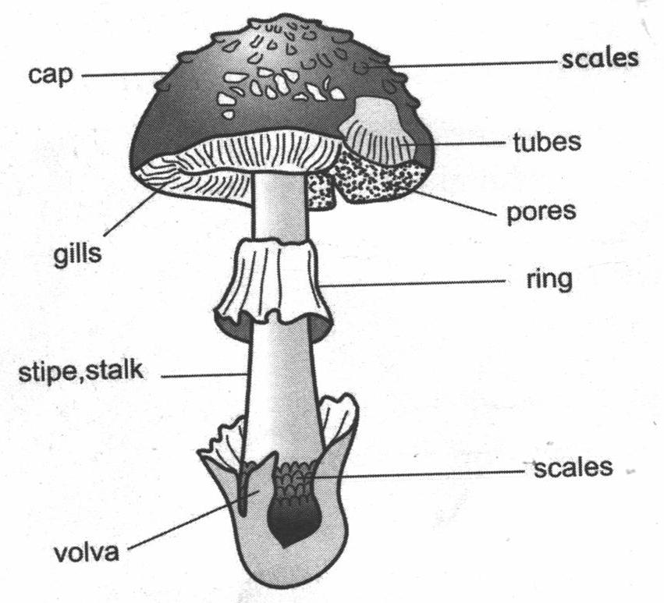Figure 3.5: Parts of a mushroom.
- The following are the functions of various parts of a mushroom
- Stalk (stem/stipe)
- Used to support the cap
- Channels water to the cap
- Gills
- Produce spores (seeds for mushroom)
- Ring / Annulus
- A membrane located under the cap circling the stem.
- *It is the remnants of a membrane that covered the raptured grills as the cap grows.
- Cap/Pileus
- It supports and protects grills and spores.
- Volva
- These are remnants of a membrane that covered the immature mushroom
- Scales
- These are rough patches of tissue on the surface of the cap.
- Veil
- A thin tissue that connects the cap to the stem in young mushrooms.
LIFE CYCLE OF FUNGI
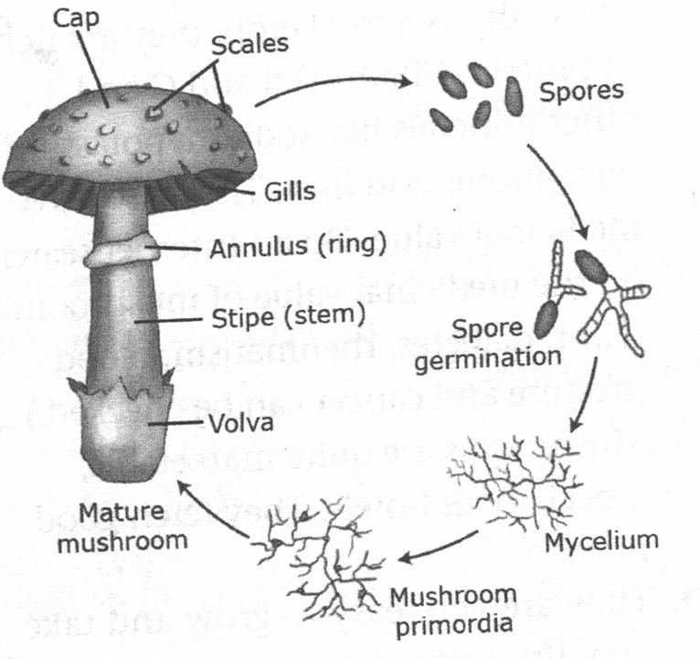 Figure 3.6:
- The cap produces spores, which upon falling on favourble environment, will germinate to form mycelium.
- The mycelium forms secondary mycelium through the fusion of two sexually but compatible mycelium.
- The secondary mycelium form the fruiting body (mushroom).
COMMONLY CULTIVATED SPECIES OF MUSHROOMS
- Some of these species are:
- Oyster (Pleurotus SPP)
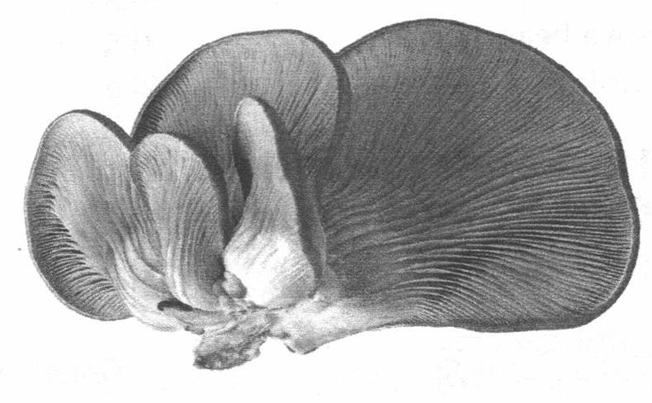Figure 3.7: Oyster Mushroom
- Brown to gray or cream in colour.
- It has a large fan – like cap and short stem.
- A good flavor when prepared.
- Can be eaten raw in salad, but mostly cooked.

- Button (Agaricus SPP)
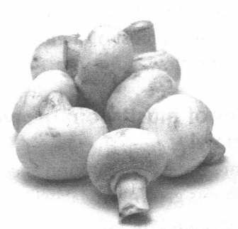Figure 3.8: Button mushroom

- Dome shaped
- White to light brown colour.
- Has a nice flavor
- Can be used raw or cooked.
- Can be canned and dried
- Shiitake (Oak mushroom, Chinese black, forest mushroom, golden oak)
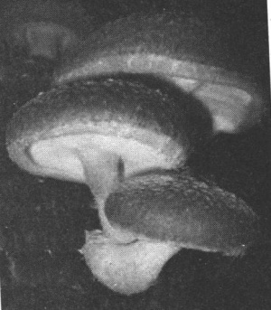 Figure 3.9 : Shiitake Mushroom

- It tastes like steak when cooked
- Its colour ranges from tan of dark brown
- Has broad umbrella shaped caps.
- Straw (Paddy straw)
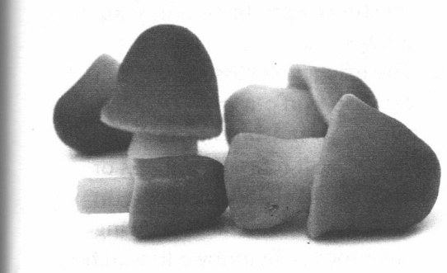Figure 4.0: Straw Mushroom
- It is pink in colour and grows on rice straw beds.
SPECIES OF MUSHROOM GROWN IN MALAWI
- The two main types of cultivated mushrooms in Malawi include Oyster and Button.
DIFFERENCES BETWEEN OYSTER AND BUTTON MUSHROOMS
- Oyster mushrooms are easier to grow than button mushrooms.
- Button mushrooms have a better taste than Oyster mushrooms.
- Oyster mushrooms are less capital intensive than button mushrooms.
- Oyster mushrooms have a shorter shelf-life than button mushrooms.
- Oyster mushrooms fetch lower prices on the market than button mushrooms.
- Oyster mushrooms are good for beginning farmers because they are easier to grow tan button mushrooms.
IMPORTANCE OF MUSHROOMS
- Mushrooms are used as food and source of nutrients such as vitamin C, Vitamin B12 (cynocobalamine), calcium, iron, potassium, Phosphorus etc.
- Mushrooms are used as medicines
- Garnoderma lucidum is used to treat ailments such as fatigue, coughing, asthma, indigestion, neurosis and inhibition of HIV multiplication.
- Mushrooms can be sold to earn income.
- Mushrooms help in cleaning the environment by recycling farm wastes.
- The resulting compost (spent compost) is used as manure or animal feed.
- Mushroom is used for industrial purposes i.e. raw materials in soups, Pizza and manufacture of colourings and absorbents.
- Mushroom growing as source of employment.
- There is labour demand in production, processing and marketing.
CHOOSING SUITABLE SPECIES FOR MUSHROOM PRODUCTION
- Some factors to consider when selecting species of mushrooms to grow include:
- Availability of waste materials to use as growth medium.
- Presence of suitable environmental conditions.
- Availability of expertise in growing the mushrooms.
- Availability of capital
- Market demand for the species of mushrooms to be cultivated.
HUSBANDRY PRACTICES FOR MUSHROOM PRODUCTION
- The following are husbandry practices involved in mushroom production:
- Species selection
- Site selection
- Construction of an incubation and production shed
- Substrate preparation
- Substrate treatment
- Spawn source (buying or preparation)
- Mushroom seeding
- Watering
- Mushrooms fruiting management
- Mushroom harvesting
SITE SELECTION
- The following are qualities of a suitable site for producing mushrooms:
- Availability of waste materials to use as a growth medium.
- Climatic conditions: Mushrooms require warm and moist conditions for faster development.
- Nearness to a dense forest: This provides ideal conditions for mushroom growth because of humidity and availability of wood.
- The area must be pest and disease – Free.
- Nearness to the market to enable the produce to get the consumers when they are fresh.
- Readily available clean water for watering to avoid contamination.
- Availability of transport for both produce and substrate materials so that they reach their area of need faster.
- Availability of growing mushrooms resources (equipments) such as mushroom bags, bottles etc.
- Availability of expertise in growing mushrooms. Some mushrooms are more difficult to grow compared to others.
CONSTRUCTION OF INCUBATIONN AND FRUITING PRODUCTION HOUSE OR SHED
- Houses range from simple to sophisticated.
- Materials for house construction will include poles, thatch grass, twigs and bamboo strips, black and clear plastic sheets, nails, panga knives, hammer, solignum, sand, pegs etc.
- When constructing the house for incubation the walls and roof should be covered with black plastic sheets (incubation house) to allow high (O₂ concentration for mycelia colonization)
- Fruiting houses are generally constructed using a clear plastic paper to allow sufficient light for the formation of fruiting bodies of mushrooms.
- Both incubation and fruiting houses should have shelves.
- The shelves can be made from bamboo or wooden bricks.
- The size of the house will vary depending on the amount of mushrooms you want to produce.
- The floor should be solid and slopping for ease of cleaning to allow excess water to drain.
- It can be made of cement if available.
- Sand should be put on the floor since it helps to absorb water.
- The mushroom house should face the windward side and should be shielded from the sun.
- The house should be well ventilated.
SUBSTRATE PREPARATION
- A substrate is an organic material on which mushrooms obtain their nutrition.
- Examples of materials used as substrates include chopped maize stalks, logs, banana leaves, rice straw, wheat, sorghum, sugarcane bagasse, finger millet stems, tea leaves, coffee grounds, rice bran, sawdust and cotton waste.
- Most farmers in Malawi use chopped maize stalks.
PROCEDURES FOR PREPARING SUBSTRATE
- Chop the maize stalks into small pieces of about 2.5cm in length using a panga knife.
- Soak the substrate material for some time.
- Remove the water and dry the materials. Ensure that it is not too dry.
- Keep the material under the shade.
- Fill the substrate material firmly in clear plastic bags.
- Tie the bags with sisal or rubber band.
- Sterilize the substrate using an old oil drum (210 litres)
TREATING OR STERILISING SUBSTRATE
- Substrates are treated in order to kill disease causing organisms.
METHODS USED TO TREAT SUBSTRATES
- PASTEURIZATION USING THE DRUM METHOD
PROCEDURES:
- Put 10 liters of water in the drum
- Cover the water with a wooden rack or perforated round metal sheet. The platform is provided by bricks placed at the bottom of the drum.
- The wooden rack or metal sheet and sides of the drum should be covered with cardboard to protect the bags from heat.
- Fill the drum with the substrate material and cover it with a black or clear plastic sheet.
- Make a hole in the middle of the plastic sheet to serve as a safety valve.
- Tighten the drum with sisal.
- Put the drum on fire and heat for about an hour.
- Maintain the fire at around 110 ⁰C so that the material is thoroughly sterilized against bacteria and other Fungi e.g. Trichoderma (green mould, a common diseases in Oyster mushrooms)
- After heating, leave the substrate to cool for some time.
- Temperature must remain constant and these should always be water in the drum.
- Pasteurization using pasteurizing room
PROCEDURES:
- The pasteurizing room has shelves, boxes or well cleaned floor on which the substrates are placed.
- Pipes connected to a water container are passed through the closed room and the water in the container is made to boil.
- Hot steam makes in the pipes into the pasteurization room and complete pasteurization takes 6 – 8 hours.
- The substrates are then allowed to cool down to about 25 ⁰C while the room remains closed.
- Faster cooling can be achieved through injecting in cool air via the same pipes.
- PASTEURIZATION USING THE SUN.
PROCEDURES:
- Substrates are cleaned with water and pre-wetted to ensure that they absorb and retain enough water.
- Pre-wetted substrates are wrapped and tied tightly in plastic bag and left on the sun for some hours.
- The substrates are turned regularly to provide uniform treatment.
- The heat which is generated with the plastic bag sterilizes the substrates.
- Groundnuts shell can be easily pasteurized in this way.
- When using g/nuts shells, it is advisable that 1% lime and gypsum be added.
- Lime reduces acidity of the substrate while gypsum avoids lamping of the substrates.
- WASHING WITH SOAP.
- The technique is quick and cheap but renders the whole production process risky.
PROCEDURES:
- Dip the substrates in water to remove dirt.
- After removing dirt, the substrates are dipped in another container containing soap (powder/liquid).
- This soap used is capable of killing certain microbes but to very significant levels.
- Excess soap is removed by dipping the substrates in another container containing clean water.
- Clean substrates are packed in sacks which are placed in strategic positions to ensure that excess water is drained.
- Supplements such as wheat and rice bran can be added to reach optimal C/N ratio.
SPAWN PRODUCTION
- Spawn means mushroom seed.
- In other words, spawn refers to mycelium on a substrate used as planting materials in mushroom cultivation.
- Spawn production means putting mycelium of the chosen mushroom species in the substrate which is sterilized under controlled conditions.
- Spawn production in Malawi is done at Natural Resources College (NRC), Bvumbwe Research Station, Chancellor College and Bunda College.
- Spawn is prepared in a clean laboratory under very strict hygienic conditions to avoid contamination.
- It requires expertise.
- The process of spawn production include:
- Tissue culture preparation
- Inoculating the culture in the test tubes or petri-dishes.
- Spawn multiplication using materials like sorghum, millet and whole rice.
- Further multiplication of spawn into different generations (generation 1, 2 and 3)
TISSUE CULTURE PREPARATION
- This process has two stages:
- Culture medium preparation
- Tissue culture preparation
CULTURE MEDIUM PREPARATION
- A culture medium is a substance on which the mushroom Fungi will be grown.
- In other words, it is a nutrient substance (solid or liquid) that is used to cultivate micro-organisms.
AGAR SUBSTTRATES
- Most mushroom species grow on potato Dextrose Agar PDA or Malt Extra Agar media.
- Potato Dextrose Agar is a common medium.
- It is in a powder form when commercially purchased.
- Prepared simply by adding 20g PDA powder to 1 litre distilled water.
- Then mix it thoroughly through stirring.
LOCAL PREPARATION OF POTATO DEXTROSE AGAR (PDA)
STEPS:
- Wash and weigh 200g European potatoes or ordinary potatoes and cut them into small pieces.
- Boil for about 15 to 20 minutes in 1litre water until they are soft. Drain and save the water.
- Make the water back up to 1litre with fresh water
- Add 20g dextrose (glucose) and 20g agar into 1litre distilled water.
- Heat until the agar dissolves. The agar made is called Potato Dextrose Agar (PDA).
- You can purchase already made PDA.
- The formula for PDA is:
Potatoes 200g
Dextrose 20g
Agar powder 20g
Distilled water 1litre
- Put the agar into containers, plug and sterilize in an autoclave at 121⁰C for 15 minutes.
- After sterilization slant the bottles or containers.
- This is done to allow a maximum surface area for mycelium.
- The culture medium is poured into test tubes ( ¼ full) while it is in liquid form.
- Fill the test tubes or petri dishes on a Laminar Air Flow table after sterilizing them.
- Let the medium cool on the Laminar Air Flow table.
*NOTE*
- A Laminar Air Flow table is an enclosed bench designed to prevent contamination of biological samples.
- The device separates our flowing through it into layers.
TISSUE CULTURE COLLECTION AND PREPARATION
PROCEDURES:
- Wash fresh and tender mushroom thoroughly.
- Dip the scapel in alcohol and then flame it until red hot.
- Let it cool down for 10 seconds.
- Now break or tear the mushroom lengthwise with hands.
- Do not cut it with a knife, since contaminants from the surface can stick to the blade.
- Do not touch the inner surface with your hands to avoid contamination.
- Use the heated scapel to remove a small piece (2x2mm) of the inner tissue.
- Take care that no outside surface tissue is included.
- Open the test tube/petri dish containing the culture medium.
- When using test tubes, heat the mouth of the tube in the flame to kill unwanted spores.
- Then gently place the tissue on the scapel in the middle of the agar.
- Seal peetri-dishes with clear cello tape or masking tape while test tube are plugged with cotton wool.
- Place the test tubes and petri dishes in an incubator at a temperature between 25⁰C – 30⁰C for 10 – 15 days.
- After 15 days of incubation mycelium will cover the tissue and branch out on the agar.
SPAWN COLONISATION
- The following materials are suitable for spawn making: sorghum, millet, whole rice and wheat.
PROCESS OF SPAWN COLONISATION
- Soak the material (sorghum/millet/wheat) in water for a day.
- Remove the water.
- Sterilize the material at 121⁰C for 30 minutes.
- Prepare 300 millilitre bottles and sterilize them for 15 minutes (bottles that can withstand strong heat)
- Put the material into bottles ( ¾ full)
- Sterilize again for 30 minutes.
- Cool the material.
- Inoculate the tissue culture into the bottles containing sorghum/millet/rice or wheat.
- With one petri dish you can inoculate 16 bottles. This is called generation 1.
- Each of the 16 bottles can be used to produce 10 bottles of spawn, a total of 160 bottles. This is called generation 2.
- Each of the 10 bottles can produce another 10 bottles of spawn. This is called generation 3.
- Farmers use generation 3 to grow mushrooms.
- One test tube can inoculate 4 – 5 bottles.
- Put the inoculated bottles into an incubator for 15 days for mycelium colonization.
SPAWNING/SEEDING THE SUBSTRATE
PROCESS:
- Wash hands with alcohol.
- Spawn bottles should be stroked with a piece of wire or you can shake them.
- Open the substrate bags and put the spawn into them.
- The substrate should be spawned as soon as it has cooled below 25 – 30 ⁰C.
INCUBATION
- Spawned substrates should be taken to the incubation house.
- Make holes in the bags for aeration and to enable the mushroom to sprout.
- Place the bags in shelves and cover them with black plastic sheet for 21 days.
- The mycelium will colonise the substrate and start to form small fruiting bodies.
FRUITING/CROPPING
- The colonized bags should be taken to a fruiting house.
- During fruiting it is important that the house is kept damp, but not wet to allow the mushroom to grow.
- This is done by watering the bags three times a day depending on the weather conditions.
- A sprayer or a broom can be used to spray the bags.
- The temperature in the fruiting house should not be above 20 ⁰C.
- Humidity is of great importance in a mushroom house.
- Temperature can also be controlled by opening the doors and windows at night.
PESTS AND DISEASES OF MUSHROOM
PESTS OF MUSHROOMS
They include flies, rats, snails and mites
- PHORID AND SCIARID FLIES
- Flies do not harm mushrooms but they lay eggs on the mycelium.
- The larvae (maggots) which eat and damage stipes, gills and mushrooms themselves.
CONTROL
- Keeping the fruiting rooms clean.
- Removing the old contaminated bags regularly.
- Setting up fly light traps.
- Nematodes prey on the mushroom fly larvae.
- RATS
- They damage the substrate bags.
CONTROL
- Keeping cats which prey on rats.
- Keeping the surroundings clean
- Setting traps.
- SNAILS
- They eat mushrooms at night
CONTROL
- Handpicking and killing them.
- Brits and traps
- Use of salt is effective in controlling snails.
- MITES (TINY SPIDERS)
- They eat the mycelium or the actual mushroom.
- They are carries of green mould caused by Trichodering and other Fungul diseases.
CONTROL
- Spraying malathion
- Sprinkling quick lime.
MUSHROOM DISEASES
- TRICHODERMA (GREEN MOULD)
- Is the most common disease of Oyster mushrooms
- It is air – borne.
- It is transmitted by flies, mites and human handling.
- It grows when there are crakes in the substrates.
- Trichordema appears as spots on dead mushrooms and substrates.
CONTROL
- Keep the substrate dry since it is prompted by moist conditions.
- Remove and destroy the contaminated substrates.
- Disinfecting the mushroom house using Deosan super or Adecol.
- Other mushroom diseases include: long stipes, fat stems, dry bubble, lob web, blotch (bacterial disease) and dieback (virus disease).
HARVESTING AND MARKETING
- Time and method of harvest are very important factors to consider.
TIME OF HARVEST
- Mushrooms should be harvested when they are ready i.e. when mushroom caps have enlarged but the cap margin (edge) is still curved down.
- Mushrooms are ready for harvesting (in the fruiting house) in fire days if the temperatures are kept between 15 ⁰C and 20 ⁰C.
METHODS OF HARVESTING
- Grasp the entire cluster firmly, then twist and pull outward.
- The lower portion where the mushrooms were attached to the substrate can be trimmed off if the mushrooms are to be stored in a refrigerator.

T0PIC 12: LIVESTOCK FEEDS AND FEEDING
CLASSES OF LIVESTOCK FEEDS AND THEIR CHARACTERISTICS
The two classes of livestock feeds are roughages and concentrates.
ROUGHAGES
These are feeds with high moisture and fibre content but low in protein content.
TYPES OF ROUGHAGES
- Succulent roughages
- These are animal feed stuffs with high water content.
- Succulent roughages includes fresh grass, or green folder for example; elephant grass (Napier grass), guinea grass, giant star grass, silage, banana stems, leucuena, cabbage leaves.
- Dry roughages
- These are dry animal feed stuffs with high fibre content.
- Dry roughages have also the following characteristics:
- Low digestibility
- Low in nutrient content
- Provide less energy
CONCENTRATES
- These are feed which are high in protein and carbohydrates and low in moisture and fibre content
- They are the main diet of the non-ruminant animals.
- They are two types of concentrates namely energy and protein concentrates.
- Energy concentrates
- These are feeds high in digestible carbohydrates
Examples
- Cereal grains and their by-products such as maize meal, madeya, wheat meal, sorghum and millet.
- Fats and oils.
- Protein concentrates
- These feeds are high in protein content
Examples
- Meat and bone meal, blood meal, fish meal
- Legumes and their by-products such as groundnut meal, bean meal, soya meal.
*NOTE*
- In addition to roughages and concentrates, animals are given additives such as mineral and vitamin supplements.

FUNCTIONS OF NUTRIENTS IN LIVESTOCK FEEDS AND THEIR SOURCES
- WATER
FUNCTIONS OF WATER
- Helps in transportation of food nutrients within the body.
- Lubricates the body joints
- Helps in regulation of body temperature
- Maintains the shape of the body by keeping the cells turgid
- Essential for body fluids.
SOURCES
- Drinking water
- Succulent feeds
- CARBOHYDRATES
- They are rich in energy reserves
SOURCES
- Grass
- Root tubers such as cassava
- Potato vines
- Cereals such as maize, sorghum, madeya
- FATS AND OILS
- They are related to carbohydrates because they contain C, H and O.
FUNCTIONS
- Provides energy twice as much energy as carbohydrates
- They are carries of fat soluble vitamins (vitamins A, D, E and K)
- Excess fats stored in the body act as an insulating layer in animals’ bodies and prevent heat loss.
- They are essential constituents of body cells.
SOURCES
- Oil seeds such as groundnuts and cotton seeds
- Soya beans
- Milk, eggs, meat
- Fish meal and bone meal
- PROTEINS
- They are complex food substances made up of amino acids.
FUNCTIONS
- For body building and repair of worn out tissues
- Excess proteins are converted into energy
- Essential components of enzymes, hormones and antibodies
- Provide immunity to diseases through antibodies
SOURCES OF PROTEINS
- Grain legumes such as beans, soya beans, g/nuts.
- Meat, liver, milk
- Bone and fish meal
- VITAMINS
These are organic compounds which regulate various body processes for health, growth and reproduction.
- Vitamins are classified according to their solubility
- Fat soluble vitamins: such as vitamins A, D, E and K
- These vitamins can easily be stored in the body
- Water soluble vitamins: such as vitamin B complex and Vitamin C.
FUNCTIONS
- They act as co-enzymes (organic catalysts) in the body reactions
- They promote healthy growth of animals
- They prevent diseases in animals
- They help in muscular activity
- Vitamin A helps to improve eye vision.
- Vitamin K helps in the blood clotting
SOURCES OF VITAMINS
- Vitamin D
- Egg yolk, milk, green grass
- vitamin A (Retinol)
- Carrots, yellow maize, liver oils, tomatoes, hay, silage.
- Vitamin E
- Hay
- Cereal grains
- Oil seed
- Vitamin C
- Citrus fruits and green leafy vegetables
- Vitamin K
- Hay, egg yolk, cereal grains
- MINERAL SALTS
- They are required in small amounts
FUNCTIONS
- They are complex of hormones such as thyroxin hormone.
- Help in maintenance of correct acid – base balance in the body fluids.
- Formation of animal products such as milk and eggs for example calcium and phosphorus.
- For formation of bone and teeth such as calcium, phosphorus and magnesium.
- Examples include: milk, meat, egg yolk, common salt, cereal grains.

FEED RATION
- It is the feed or feed mixture which contains all the essential nutrients in the right quantity and quality as needed by the animal
- Feed ration can be classified into two:
- Maintenance ration
- Production ration
MAINTENANCE RATION
- Is the amount of feed that the animal needs per day to maintain its bodily processes without gaining or losing weight.
FUNCTIONS OF MAINTENANCE RATION
- To supply heat for proper maintenance of body temperature
- To repair the daily wear and tear of the body tissue.
- To compensate the loss of mineral from the body
- To provide essential nutrients, particularly vitamins for maintenance of life and well being.
- To supply energy for proper functioning of heart, brain, lungs and other vital body organs.
PRODUCTION RATION
- Is the amount of feed that contains all the essential nutrients in the right proportion given to animals for growth, fattening, milk or egg production.
FEED FORMULATION
- It is the combination of ingredients to satisfy the nutritional requirements of a certain type of animal
WAYS OF FEED FORMULATION
- The commonly used method of feed formulation is called Pearson’s square method.
- In order to use this method, there is need to know the following
- Animals’ feed requirement
- Nutrient composition of the ingredients and its target only protein.
Steps to be followed when formulating feed using Pearson’s square method.
- Mixing 2 ingredients (protein and energy source)
- Draw a square
- Put the target protein level at the centre.
- The target protein level is the feed requirement of the animal in the question and protein content is the basis
- Place a protein source ingredient at the top left corner of the square and energy source ingredient at the bottom left corner.
- Subtract across the diagonal (smallest number from largest)
- Add the two numbers on the right-hand side of the square and the total value is the total parts
EXAMPLE 1
- A farmer wants to formulate a 18% protein feed of her broiler chickens using cotton
- seed meal (CSM) containing 40% protein and grain containing 10% protein. Using a Pearson’s square method, show how the feed can be formulated.
- Solution
8 parts cotton seed meal

18%
Cotton seed meal 40

% grain 10
22 parts of grain

Total parts: 22 + 8 = 30 parts
- Cotton seed cake $= \frac{8 parts}{30 parts}×100 =26.67\%$
- Grain $=\frac{22 parts}{30 parts}×100=73.33\%$
Therefore the feed will contain 26.67% cotton seed meal and 73.33% grain.
- If the farmer want to firm 150kg feed. Calculate the quantity of each ingredient in kilograms.
Solutions
- Cotton seed = $\frac{26.67}{100}×150kg=40.005kg$
- Grain = $\frac{73.33}{100}×150kg=109.995kg$
- Mixing three ingredients (one protein and two energy sources).
EXAMPLE 2
- A farmers wants to formulate a 30% protein feed using soya beans which contains 40% protein and wheat and maize bran as energy sources of the feed containing 15% and 10% protein respectively. Use a Pearson’s square method to show how the feed can be formulated.
17.5 parts soya (30-12.5)
Soya bean meal 40%

30%
Maize bran 10%
Wheat meal 15%
Average (10+15)=12.5%
10 parts (MB+WM)
(40-30)

Total = 27.5 parts
- Soya bean will be: $\frac{17.5}{27.5}×100=63.6 \%$
- Wheat + maize bran: $\frac{10}{27.5}×100 =36.4\%$
- Wheat = 36.4% $÷2=18.2\%$
- Maize bran =$36.4\%=18.2\%$

IMPORTANCE OF FEEDING LIVESTOCK
- Animals give high yield of meat, milk and eggs
- They provide high quality meat, milk and eggs
- They give high energy output on the farm especially Oxen.
- They give high market value when taken to the market.
- To reduce deficiency diseases.
FACTORS TO CONSIDER WHEN FEEDING LIVESTOCK
- Age of the animal
- Young animals require less feed than larger animals since their digestive system is not fully developed to digest solid feed.
- Size of the animal.
- The larger the animal, the greater the amount of feed required

- Type of the animal
- Ruminant animals can digest roughages while most non-ruminant animals cannot digest roughages.
- Cost of the feed
- Expensive feed is given to animals that are productive enough to yield a profit.
- Condition of the animal
- Thin animals require more and better quality of feed in order to bring them back into condition.
- The quality of the feed
- The feed should be nutritious in order for livestock to obtain all the essential nutrients and be healthy.
- Digestibility
- Feed becomes useful if the animal can break it down for absorption
- Purpose of which the animals are kept
- Animals kept for drought require high energy feed while animals kept for milk, meat and eggs need protein concentrates.

TOPIC 13: SHEEP AND GOAT PRODUCTION

- Sheep and goats are small ruminant animals that most farmers keep.
SHEEP PRODUCTION
- Meat: People obtain proteins and other nutrients from mutton
- Wool: a good source of raw materials for the textile industry
- Skins: leather from sheep hides is used for making shoes and jackets.
- Income: live sheep and mutton can be sold for cash.
- Employment: rearing sheep provides jobs for people.
BREEDS AND BREEDING OF SHEEP
Name of breed uses
- Malawian sheep – meat, hides, manure.
- Dorper – meat
- Hampshire Down – meat
- Karakul – meat and skin
- Black head Persian – meat and skin
- Merino – mostly wool
- Dorset horn – mutton and wool
- Only the Malawian sheep is indigenous. The rest are exotic.
SELECTION CRITERIA FOR BREEDS OF SHEEP TO REAR
The following factors should be considered in selecting a sheep breed for (meat) mutton.
- Body conformation: should be reasonably big
- Growth rate: should grow fast, mature early and produce more lambs.
- Adaptation to the local climate and environment: should be able to withstand hot and dry weather conditions (local conditions)
- Efficiency in converting feed: should be efficient in converting grass into meat.
- Quality of mutton: the sheep should be able to produce quality mutton.
- Good mothering ability: the ewes should be able to produce sufficient milk for lambs.
The following are some of the characteristics to look for in sheep breeds raised for wool:
- The breed should able to produce a lot of fine wool; (8 – 10cm)
- The breed should be able to survive on local pastures which are generally low in nutrient content
- Ewes selected for breeding should be:-
- Healthy
- Be of a good size
- Have high milking ability
BREEDING PERIOD
- Ewes should be allowed to mate with the ram when they are about 18 months old. (but 2 years is recommended)
- The ideal time to breed sheep in Malawi is November so that lambing is done in April to May.
- Breeding in November has the following advantages:
- There is plenty of grass for grazing.
- The lambs are less likely to pick up worms as they start grazing since the rains are almost over by this time
- One ram can service up to 40 ewes.
CASTRATION
- Rams not needed for breeding should be castrated
- Castration is normally done when the lambs are 1-2 months of age.
INSTRUMENTS FOR CASTRATION
- The burdizzo – is used to crush spermatic cords above testicles.
- This method is used when the animals are about 2-3 months old.
- Using a sharp knife – cut open the scrotum or sac containing testicles (remove testicles)
- The cut should be treated with disinfectant to prevent infection.
- Using a rubber band or elastrator – the rubber band is placed on the scrotum above the testicles and cuts off the blood supply to the testicles.
- This method is used when the animals are up to 1 week old.

REASONS FOR CASTRATION
- Castrated animals fatten up quickly and they produce quality meat.
- Castration prevents low quality animals from mating and passing on less desirable characteristics
- It makes the animals more docile, hence, easier to handle.
- To prevent transferring of breeding diseases.
AGE AT PUBERTY
Puberty is the period when the animal becomes sexually mature.
- Female sheep (ewes) reach puberty at 6-10 months.
- Ewes need to be flushed before mating
- Flushing means the process of feeding concentrates to ewes 2 to3 weeks before and after mating period.
- Flushing helps to increase their fertility levels and chances of conception.
- The ram lamb can be used for breeding when it is about 8 months old.
GESTATION PERIOD
- The gestation period in sheep lasts for five months (150 days)
- During this period ewes need to be steamed up.
- Steaming up mean the practice of giving concentrates a few months before ewes give birth.
LAMBING
It means the process of giving birth (parturition) in ewes.
SIGNS FOR LAMBING
- The ewe becomes restlessness.
- Ewes tend to leave the rest of the flock and search for a quieter place.
- The vulva becomes red
- Frequent bleating
- Loss of appetite.
  - Usually lambs are born with the head and forelegs in front.
  - As soon as the lambs are born they should be assisted to suckle their mothers.
CARING FOR LAMBS
The following management practices should be carried out when caring for lambs:
- Lambs should suckle up to the age of six months.
- Providing supplementary feed as milk yield declines.
- Vaccinating and drenching lambs against parasites and diseases
- Docking (cutting of the tail)
- Hoof trimming (cutting back overgrown hooves)
- It is done to prevent lameness
DOCKING
It is done when the lambs are about 4-5 weeks old.
REASONS FOR DOCKING
- It helps the animal to mate easily
- It helps to improve the quality of the carcass in fat tailed sheep.
- It helps in controlling external parasites from the anal area.
- It prevents dirt and dung from collecting under the tail which could be a source of infection.
HOUSING SHEEP
Sheep need to be properly housed because of the following reasons:-
- To protect them from predators attack such as hyenas, leopards etc.
- To protect them from bad weather e.g. cold weather since they easily get pneumonia.
QUALITIES OF A GOOD SHEEP HOUSE (KHOLA)
- It should be roomy
- The floor should be made of concrete
- The khola should be easy to clean
- It should have feed and water troughs
- It should be built on dry high ground to ensure that it is well drained.
- The khola should be well ventilated.
- The roof should be properly thatched with iron sheets or grass.

CONSTRUCTING A KHOLA FOR SHEEP (SIMPLE KHOLA)
Materials:
- Poles, twigs, thatch grass, iron sheets, ropes, sisal, pangas, hoes, axes, cement, wooden pegs, hammer, nails, sand.
- Select a place which is well drained
- Clear the area
- Lay out the house using a tape measure, strings, pegs and hammer.
- Stake the corners of the house using the poles
- Dig and build the foundation using stones and concrete.
- Build the walls up to the rafters
- Construct the rafters of the roof
- Thatch the roof using grass, ropes or sisal strings.
FEEDING SHEEP
Sheep are excellent grazers.
The mostly eat grass.
They are also given supplementary feed such as maize meal, madeya, bean meal, groundnut meal, cotton seed cake.
- Sheep should also be provided with salt and minerals in the form of mineral lick blocks.
- They should also be given sufficient clean water.
- Pregnant ewes, suckling lambs, servicing rams and ewes should be given the balanced ration.
- Breeding ewes should be given extra feed at least 2 -3 weeks before and after mating. This process is called flushing.
- Pregnant ewes should be given high quality feed in form of concentrates 2- 3 weeks before farrowing. This process is called steaming – up.
GOAT PRODUCTION
IMPORTANCE OF GOATS
- They are source of meat
- They provide milk
- Source of income
- Source of raw materials:- skin is used for making fabric in textile industries
- They provide manure.
BREEDS OF GOATS
There are two breeds of goats namely: Indigenous and Exotic goats.
INDIGENOUS GOATS
- These are the native of Malawi
- Mostly kept for meat production

CHARACTERISTICS OF INDIGENOUS
- It is small but produces a reasonable amount of meat
- It is disease resistant
- Can survive on local pasture
- Can walk long distances in search for pasture
- It is hardy: can withstand the local climatic conditions.
EXOTIC BREEDS
These are imported from outside Malawi.
- South African Boer goat: kept for meat
- Anglo Nubian: kept for meat and milk
- Saanen: kept for milk
- Toggenburg: kept for milk
- Angora goat: kept for mohair.
CHARACTERISTICS OF THE SOUTH AFRICAN BOER GOAT
- It is big and grows fast
- It is resistant to some diseases and parasites
- It produces high quality leather.
- It is highly prolific (can lamb 3 times in 2 years)
HOUSING GOATS
Goats need to be properly housed in order to protect them from rain, heat, coldness and predators.
TYPES OF GOAT HOUSES
- Local khola (round khola)
- It is made of wooden poles and mud of air dried bricks
- Rectangular khola
- It is made of wooden poles, mud or air dried bricks
- Stilted khola
- It is made of timber and nails.
- It is expensive to construct and maintain.
- Brick khola
- It is made from baked bricks
CHARACTERISTICS OF A GOOD GOAT HOUSE
- It is cheap to construct.
- It is strongly built.
- It is well lit
- It is well ventilated.
- It is large enough for the number of animals to be accommodated.
- It is well drained and easy to clean.
- It has a hard floor made of concrete.

CARE AND MANAGEMENT OF THE GOAT KHOLA
- Sweeping frequently to avoid accumulation of feaces.
- Repairing the roof if any leakages are detected.
- Replacing and removing animal beddings regularly.
- Replacing broken poles.
FEEDING GOATS
- Goats are more browsers than grazers.
- They feed on pastures, herbs, shrubs and crop refuse.
- Goats need to be given supplementary feeds in the form of concentrates such as maize meal, madeya, groundnut meal, cotton seed meal and cow peas.
- They also need to be given plenty of fresh clean water.
MANAGEMENT SYSTEMS OF GOATS
There are three systems of managing goats namely:
- EXTENSIVE SYSTE
- Goats are free to browse natural pasture, trees and shrubs under the supervision of a herder.
- SEMI – INTENSIVE SYSTEM
- Under this system goats are housed at night and fenced in paddocks during the day.
- They feed on pasture grasses, legumes and shrubs in the paddocks.
- TETHERING
- Goats are housed at night and adults one tethered (tied) during the day.
- INTENSIVE SYSTEM
- It is also called zero grazing or stall feeding.
- Under this system goats are kept in the house all the time and feed is brought to them
AGE AT PUBERTY
- Does or nannies are served at 15 – 18 months old so that they can kid (give birth) at 2 years of age.
- Billies (bucks) are used when they are nine months old but two years is recommended.
- One Billy can service up to 25 – 30 nannies.
THE OESTUS CYCLE
- It is the heat period
- The length of the Oestrus cycle in goats is 18 to 21 days.
- The heat period last for one to three days.
SIGNS OF HEAT
- The nanny shows the following signs when it is on heat:
- Frequent wagging or twitching of the tail
- Excitement
- The vulva becomes red and thick.
- It mounts other nannies.
- Mucous discharge from the vulva
GESTATION PERIOD
- The gestation period in goats is about 150 days.
- Nannies can give birth twice a year.
- The process of giving birth to young ones in goats is called kidding.
SIGNS WHEN A GOAT IS ABOUT TO KID
- The udder swells
- Frequent bleating
- The animal becomes restless and nervous.
- Mucous discharge from the vulva
- Lack of appetite.
CARING FOR KIDS
- Allow the kids to suckle the colostrums in the first for days.
- Introduce supplementary fees 3 weeks after birth.
- Castrate male kids about three weeks after birth.
- Trimming the hooves
- Vaccinating and drenching against diseases and parasites.
COMMON DISEASES IN SHEEP AND GOATS
- FOOT AND MOUTH DISEASE
- It is caused by a virus called enterovirus.
SIGNS AND SYPTOMS
- Great reduction in milk production.
- Profuse and continuous salivation.
- Sores (blisters) in the mouth, teats and between the hooves.
- Lameness due to vesicles (sores).
- Inflammation of the tongue.
CONTROL
- Imposition of quarantine in outbreak cases.
- Vaccination after every six months.
- Disinfect the animal’s hooves.
- Slaughter, bum and bury infected animals.
TREATMENT
- Giving the animals antibiotics and multivitamins.
- MASTITIS
- It is caused by a bacterium.

PRE-DISPOSING FACTORS
- Teat sores.
- Injury to the udder or teats.
- Incomplete milking.
- Pendulous udders.
- Poor milking hygiene in dairy goats.
SIGNS AND SYPTOMS
- Blocked teat camas.
- Blood clots (pus in milk)
- Inflammation of the udder
- Drop in milk yield
- Rapid and weak pulse
CONTROL
- Practising farm hygiene.
- Use good milking techniques.
- Vaccinate with mastivac once in a year.
- Test for mastitis before milking.
- Cull the diseased animals.
TREATMENT
- Administer antibiotics such as penicillin or tetracycline.
- BLOAT CAUSES
- Feeding animals with large amounts of legume and lush grass or cabbage leaves.
- Blockage of esophagus by large food particles.
- Injury to the nerve supply of the rumen.
- Abrupt change in feed given to animal e.g. very dry feeds to very succulent feed.
SIGNS AND SYPTOMS
- Profuse salivation.
- Animal lies down breathing.
- Distension of the left side of the abdomen.
- Death within hours
CONTROL
- Providing dry roughages.
- Feed livestock on wilted grass and pasture legumes’.
TREATMENT
- Exercise the sick animal by walking it around.
- Remove the gas by using a stomach pump.
- Use paraffin or turpentine mixed with vegetable oil as defrothing agents.
- PNUEMONIA
    - It is caused by a bacterium called Muycoplasma mycoides.

PRE-PISPOSING FACTORS
- Poor ventilation
- Overcrowding
- Age of the animal (young animals are more prone to the disease than adult animals)
- Dampness and Chilliness in the khola.
SIGNS AND SYMPTOMS
- Abundant mucoid nasal discharge.
- Abnormal lung sounds.
- Animal appears dull.
- Animal loses appetite
- Fever.
CONTROL MEASURES
- Keep young animals in warm houses.
- Isolate sick animals.
- Ensure proper ventilation in animal houses
- Avoiding overcrowding in animal houses.
TREATMENT
- Keep animals in warm pens.
- Giving antibiotics such as tetracycline to sick animals.
- COCCIDIOSIS
- Attacks kids and lambs
- It is caused by a protozoa called coccidian
SIGNS AND SYMPTOMS
- Copious bloody diarrhea
- Sudden death in kids
CONTROL MEASURES
- Maintain khola hygiene.
- Isolate infected animals
- Use coccidiostats in food or drinking water.
- Maintain appropriate numbers in animal houses
TREATMENT
- Providing coccidiostats in foods and drinking water.
- Use drugs such as Furazolidone.
COMMON PARASITES IN SHEEP AND GOATS
- EXTERNAL PARASITES
- Examples include lice, mites, ticks and tsetse flies.

SIGNS OF INFESTATION BY EXTERNAL PARASITES
- Emaciation
- Irritation of the skin
- Loss of hair and wool
- Sores or wounds on the skin

EFFECTS OF EXTERNAL PARASITES
- Anaemia due to sucking of blood by parasites.
- Damage to the skin.
- Death of the host animal.
- Transmission of protozoan diseases such as East Cost fever.
COMMON CONTROL MEASURES OF EXTERNAL PARASITES
- Burning infested pasture.
- Dipping or spraying
- Rotational grazing
- Remove any decomposing remains of animals and keep the surroundings clean.
- Spraying the bush with insecticides.
- INTERNAL PARASITES

- ROUND WORMS
SIGNS AND SYMPTOMS
- Retarded growth
- Scouring
- Anaemia
- Constipation
- Pot belly appearance
CONTROL MEASURES
- Avoid grazing animals on muddy grounds
- Avoid grazing animals on wet grass early in the morning when the larvae are active.
- Deworm the animals using Nilverm.

- LIVER FLUKES
SIGNS AND SYMPTOMS
- Damage the liver
- Anaemia
- Swollen abdomen
- Weight loss

CONTROL MEASURES
- Routine drenching with Nilverm
- Draining swampy areas within the farm.
- Killing intermediate host snails with copper sulphate.

- TAPEWORMS
SIGNS AND SYMPTOMS
- Pot belly
- Anaemia
- Rough hair coat
- Oedema
- Egg segments in faeces.

CONTROL MEASURES
- Proper meat inspection
- Plough the pasture land to kill the cysts
- Proper cooking of meat.
- Rotational grazing.
- Proper disposal of human waste.

References:
Ministry of Education Science and Technology (2013). Malawi Syllabus for Agriculture Forms 3 and 4 (1st Edition).
B.M. Kanjala and N.T. Kaperemera. (2018): Strides Agriculture Book 3, Blantyre: Longman Malawi (Pty) Ltd.
Anthony M. Ngowa, Peter Sigel and Daniel Cheruiyot (2012). Senior Secondary Agriculture Form 3.
Dr Wotchiwe Kalande, P. Sigei and D. Cheruiyot, C. Muggah, (2018): Excel and Succeed Agriculture Book 3, Longhorn.
George Ludoviko, 2017. Jhango Senior Agriculture Book 3, Blantyre: Jhango Publishing Company.

